WHO OWNS THE INCIDENT?
Organizational Accountability, Behavioral Drift and the Shift from Blame to Continuous Learning
A leadership and incident-learning paper for mining and high-risk operations
Prepared by James White
Safety Centrics Consulting
james@safetycentrics.ca
August 2026

Executive Summary
When a serious incident occurs, the organization naturally looks toward the point of contact: the worker who made the final movement, operated the equipment, entered the hazard zone or departed from a procedure. That person is visible, their action is concrete, and the event often appears understandable when reduced to a single decision. This simplicity is attractive, but it is frequently false.
Incidents in complex operations are rarely created at one level. They emerge from a chain of decisions and conditions that can include governance, risk appetite, work design, resource allocation, maintenance, planning, supervision, production pressure, contractor integration, team norms and individual judgment. The worker may trigger the final sequence, but the organization often shaped the circumstances in which that action became possible, practical, necessary or normal.
This paper proposes a Shared Ownership Incident Learning Model. It argues that accountability should be proportional to authority, knowledge, influence, control and opportunity to intervene. Individual accountability remains necessary, particularly where conduct is reckless, malicious or deliberately concealed. However, punishment should not be the default response to ordinary error, at-risk behavior or system-induced deviation. A punitive response can suppress reporting, hide weak signals and reduce the organization's ability to learn.
The paper also challenges investigations that stop at procedural noncompliance. A finding that a worker failed to follow a rule may describe the event mechanism, but it does not explain why the deviation occurred, why defenses failed, whether the behavior was common, or why leadership systems did not detect and correct the condition. Investigations must examine the causal network, including behavioral drift: the gradual normalization of differences between prescribed work and work as actually performed.
The measure of a mature investigation is not whether it identifies someone to blame. It is whether it makes the organization less capable of producing the same incident again.
Central proposition
The person closest to an incident may own an action, but the organization owns the conditions, controls, priorities and tolerated deviations that influenced the outcome.

Key conclusions
- Incident ownership is distributed across the organizational chain; it is not transferred entirely to the frontline because the final action occurred there.
- The investigation must distinguish immediate causes from task, system, leadership and cultural causes.
- Behavioral drift should be treated as evidence of organizational adaptation and tolerance, not merely as worker noncompliance.
- Just accountability differentiates human error, at-risk behavior, system-induced deviation, recklessness and malicious conduct.
- Corrective actions must be assigned at the organizational level capable of changing the causal condition.
- Closure should require evidence of changed work, stronger controls and sustained learning—not merely revised documents or completed training.

1. Introduction: The Convenient Location of Blame
The easiest place to locate responsibility is usually the point at which the event became visible. A mobile-equipment operator entered a restricted area. A maintainer began work without confirming an isolation. A worker positioned themselves beneath a suspended load. A supervisor signed an incomplete permit. These actions matter and must be examined. Yet an investigation that treats the final action as the complete explanation confuses proximity with ownership.
The deeper question is not simply who acted. It is who designed the work, who defined the controls, who supplied the resources, who verified readiness, who observed previous deviations, who accepted unresolved deficiencies and who possessed the authority to intervene. Ownership must follow the full chain of organizational influence.
Regulatory guidance consistently warns against investigations that focus on fault rather than underlying causes. OSHA states that investigations aimed at identifying and correcting root causes, rather than finding blame, strengthen safety performance and workforce trust. HSE similarly advises that investigations must examine why human failures occurred and identify underlying or latent causes if recurrence is to be prevented (OSHA, n.d.; HSE, n.d.-a).
This does not mean that all responsibility should be moved upward or that workers cannot be held accountable. It means accountability must be fair, evidence-based and proportionate. The same organization that asks a worker to take ownership must also require leaders to own the decisions and conditions within their control.

2. What Does It Mean to Own an Incident?
Ownership has several dimensions. A person may own an action because they performed it. A supervisor may own the immediate controls because they directed or authorized the work. Operational leaders may own persistent capacity problems, production conflicts or weak verification. Executives may own governance, resource and risk-acceptance decisions. The organization owns the collective system and the effectiveness of its learning response.
Therefore, ownership should not be treated as a single object passed to one person. It is distributed across the causal network. Different actors can hold different forms of accountability for the same incident without weakening individual responsibility.
A useful test is whether the person or function had authority, knowledge, influence, control or a reasonable opportunity to intervene. The greater these factors, the greater the expected accountability. Conversely, it is unjust to assign organizational accountability to a worker for conditions they did not create, could not authorize and lacked the means to correct.

2.1 Five levels of ownership

Organizational ownership
The organization owns its governance, operating model, risk appetite, management systems, assurance processes and capacity to control foreseeable hazards. It owns whether critical risks were adequately understood, funded and monitored.

Leadership ownership
Senior and operational leaders own the translation of corporate commitments into operating reality. They establish what receives attention, what is rewarded, what is challenged and what is quietly tolerated.

Supervisory and planning ownership
Supervisors, planners, engineers and technical specialists own the immediate design and readiness of work: sequencing, staffing, permits, isolations, equipment selection, competency confirmation and field verification.

Team and peer ownership
Work groups influence local norms. They can reinforce intervention and disciplined execution, or they can normalize shortcuts and teach newcomers how work is unofficially accomplished.

Individual ownership
Individuals own decisions reasonably within their knowledge, authority and control. Accountability becomes stronger where conduct is intentional, reckless, concealed or malicious.
Ownership rule
Accountability should be proportional to authority, knowledge, influence, control and opportunity to intervene.
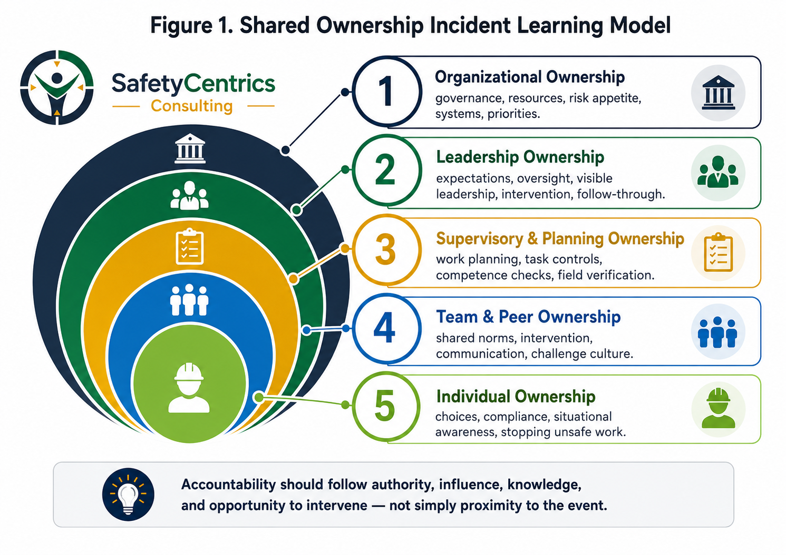
Figure 1. Shared Ownership Incident Learning Model.

3. Why Investigations Commonly Stop Too Soon
Many investigations produce technically correct but organizationally shallow findings. They identify a missing guard, an incomplete pre-start, a breached exclusion zone or a procedure that was not followed. These findings describe what failed at the point of work, but they often leave the surrounding system untouched.
The most common analytical failure is circular causation: the incident occurred because the worker performed the action that caused the incident. Rephrasing the event as noncompliance does not explain it. It does not show why the action appeared reasonable, why the control was unreliable, why supervision did not detect the condition or why the organization had not learned from earlier signals.
OSHA's root-cause guidance emphasizes that incidents often have more than one root cause. HSE's investigation guidance distinguishes immediate, underlying and root causes and stresses that failure to address human and organizational factors greatly reduces the value of the investigation (OSHA, 2016; HSE, 2004).
Complex incidents are better understood as causal networks than as single-root events. Multiple weaknesses can interact: deficient design, equipment degradation, staffing pressure, poor risk assessment, conflicting objectives, weak control verification, fatigue, normalized workarounds and incomplete corrective actions. None may independently explain the event, but together they create the pathway.
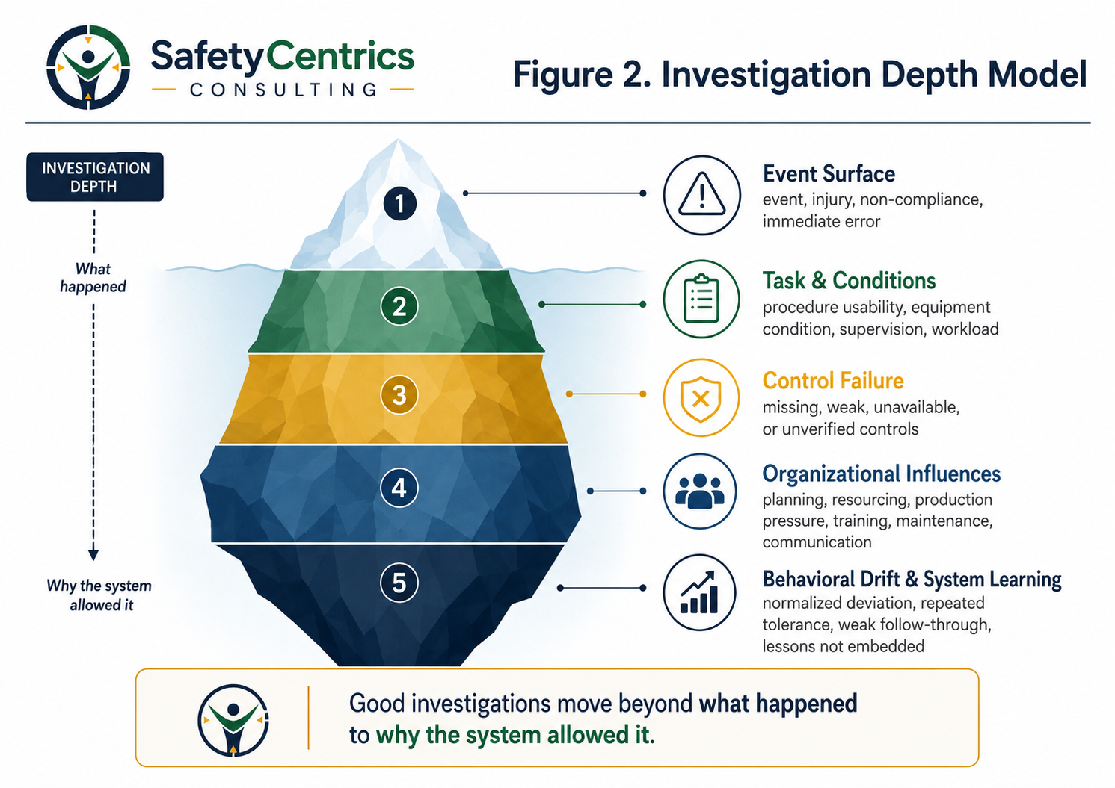
Figure 2. Investigation Depth Model.

3.1 The depth test
An investigation has not gone far enough when it cannot answer the following questions:
- Why did the action make sense to the people involved at the time?
- Was the written method practical and consistent with work as actually performed?
- Were the required controls available, reliable and verified?
- Was the deviation new, or had it become common practice?
- Who had previously observed, reported or accepted the condition?
- What leadership priorities or resource decisions shaped the work?
- What earlier weak signals, near misses or audit findings were missed?
- Why did existing assurance systems fail to identify or correct the drift?

4. Behavioral Drift: The Organizational Story Before the Incident
Behavioral drift is the gradual widening of the gap between the intended standard and actual work. It rarely begins as an open rejection of safety. It usually begins as adaptation: a crew compensates for unreliable equipment, an impractical procedure, insufficient time, poor access, missing materials or a production conflict. The adaptation succeeds. No one is harmed. Work continues.
Success is a powerful reinforcer. The temporary workaround is repeated, then shared. Supervisors become familiar with it. Leaders may observe it without challenge or may remain unaware because assurance activity examines paperwork rather than field reality. The absence of an adverse outcome is interpreted as proof that the practice is acceptable, even though control reliability is deteriorating.
Eventually, the deviation becomes the unofficial standard. New employees learn the adapted method. Risk assessments are completed around an idealized task that no longer exists. Critical controls are checked administratively but not tested in practice. When an incident finally occurs, the organization labels the behavior a violation even though the behavior may have been visible, routine and operationally rewarded.
HSE describes human factors as the interaction of job, individual and organizational characteristics that influence behavior. It also cautions that behavioral initiatives can fail when they focus on frontline actions while excluding management decisions and wider organizational influences (HSE, 2024a; HSE, n.d.-b). This is precisely why drift must be investigated as an organizational condition rather than a worker defect.
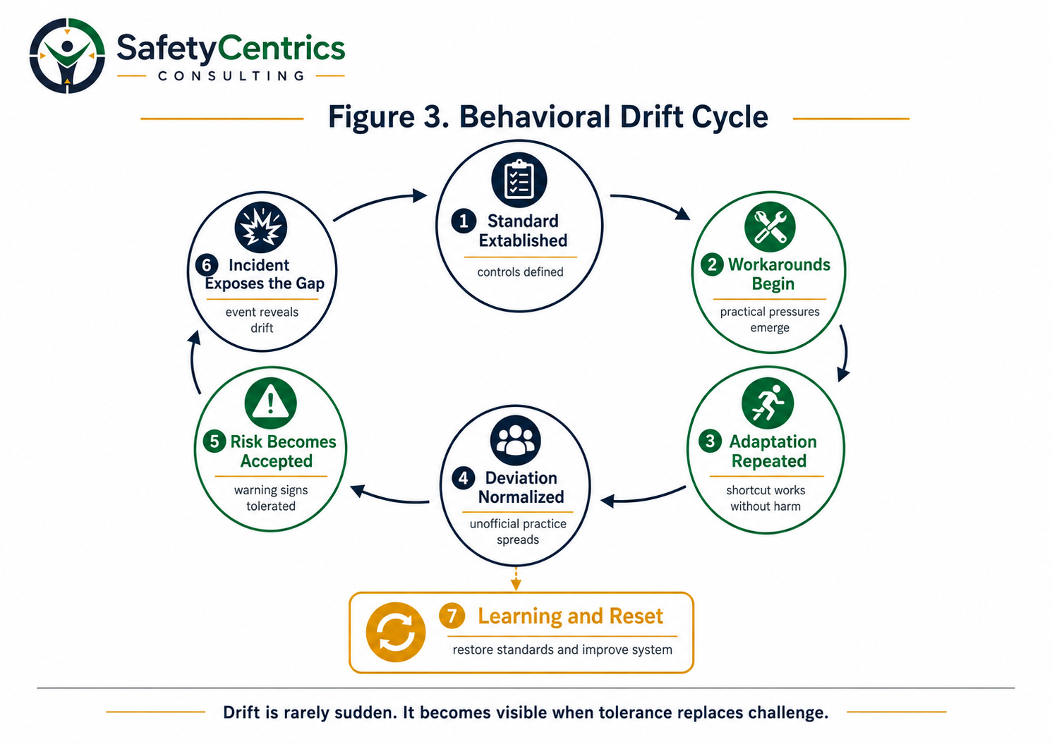
Figure 3. Behavioral Drift Cycle.

4.1 Indicators of drift
- Temporary controls remain in place long after their intended expiry.
- Procedures no longer match equipment, staffing or actual task sequence.
- Workers can describe the real method, but the risk assessment describes the ideal method.
- Known defects are repeatedly deferred without compensating-control verification.
- Supervisors accept deviations because the work has been completed that way before.
- Near misses repeat with slightly different circumstances.
- Corrective actions are closed through documentation rather than field validation.
- Production success is used as evidence that the risk is controlled.
- Critical-control checks confirm presence but not performance.
- Workers believe management already knows how the work is actually done.

4.2 The behavioral drift investigation test
Test area | Investigation question
History | Was this genuinely the first occurrence, or the first harmful outcome?
Visibility | Who knew, observed, reported or should reasonably have detected the deviation?
Reinforcement | What benefit did the adaptation provide, and what organizational pressure reinforced it?
Tolerance | Was the practice challenged, ignored, informally approved or rewarded?
Control degradation | Which prevention or mitigation barriers weakened over time?
Learning failure | What earlier event, audit or action should have prevented recurrence?

5. Human Error Is Not a Root Cause
Human error is an outcome description. It signals that an intended action or decision did not produce the expected result, but it does not explain the conditions that shaped performance. Everyone can make errors, regardless of training or motivation. The practical safety question is not whether error can be eliminated, but whether the system anticipates error and prevents it from producing serious harm (HSE, 2024b).
A mature investigation distinguishes slips, lapses, mistakes, at-risk choices, system-induced deviations, recklessness and malicious acts. Classification should follow a structured sequence: determine whether the action or omission was intended; whether harm, damage, serious deception, or deliberate concealment was the intended outcome; whether a substantial known risk was consciously and unjustifiably disregarded when a workable safe option existed; whether system conditions materially shaped or encouraged the deviation; and whether the risk was underestimated, normalized, or accepted for a perceived benefit.
Behavior category | Meaning | Preferred response
Human error | An unintended action, omission, or decision. | Console, support, learn, and improve the system.
At-risk behavior | An intentional choice in which risk is underestimated, normalized, or accepted because of a perceived benefit or competing goal. | Coach, clarify risk, remove enabling incentives, and strengthen controls.
System-induced deviation | A departure materially shaped, encouraged, or made necessary by system conditions such as impractical procedures, unavailable controls, conflicting demands, or deficient resources. | Correct the system and leadership conditions; do not use the worker as the primary corrective action.
Reckless behavior | Conscious and unjustifiable disregard of a substantial known risk when a workable safe option existed. | Apply proportionate formal accountability, alongside examination of organizational contributors.
Malicious conduct | An intentional act in which harm, damage, serious deception, or deliberate concealment is itself the intended outcome. | Apply formal disciplinary and legal processes while preserving objective investigation.
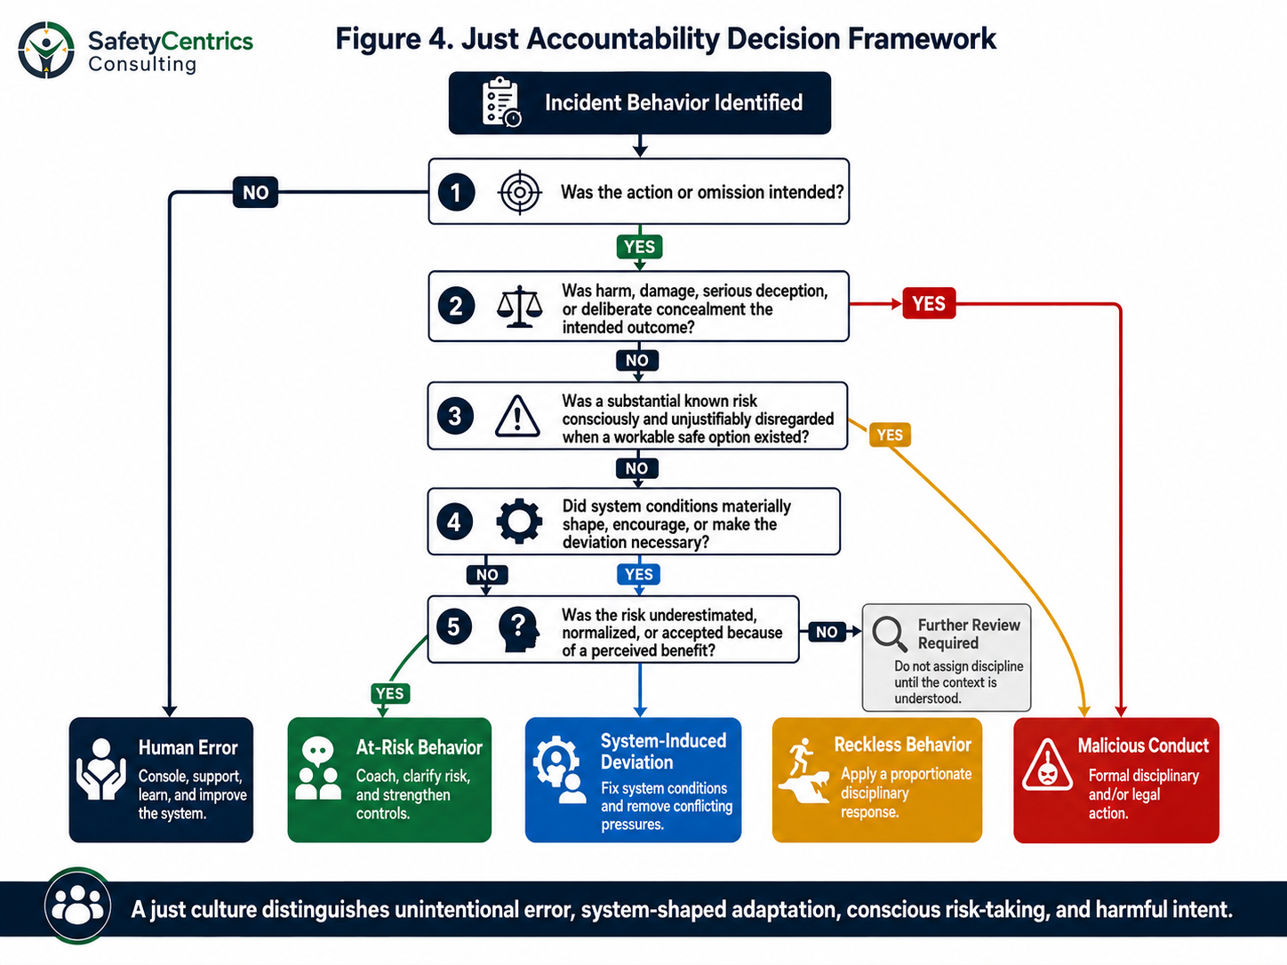
If the available evidence does not support a reliable behavioral classification, the investigation should continue gathering facts rather than forcing a premature disciplinary conclusion. The purpose of a just-accountability review is to classify behavior by intent, risk awareness, available choices, and organizational influence—not by the severity of the outcome alone.
Figure 4. Just Accountability Decision Framework.

6. The Shared Ownership Incident Learning Model
The proposed model combines accountability and learning without allowing either to displace the other. It contains four interlocking tests. Each test must be completed before the organization concludes who owns the event and what response is justified.

1. Event Accountability Test
What did each person do, know and reasonably control? What choices were available, and what consequences were foreseeable from their perspective?

2. Organizational Influence Test
What systems, priorities, resources, incentives, design decisions and leadership behaviors shaped the work?

3. Behavioral Drift Test
How had practice moved away from the intended standard? How long had the gap existed, and who had visibility or opportunity to intervene?

4. Learning Effectiveness Test
Will the proposed actions change the causal conditions, strengthen critical controls and reduce the organization's capacity to reproduce the event?
Model principle
Distributed accountability does not dilute accountability. It places each finding with the person or organizational level capable of owning and changing it.

7. The Continuous Learning and Just Accountability Cycle
The response to an incident shapes the quality of evidence that the organization will receive. When workers expect automatic punishment, they protect themselves. Accounts become defensive, weak signals remain unreported and the investigation receives a cleaner but less truthful version of work. NTSB investigations have warned that overly punitive approaches can discourage the open sharing of safety information and degrade an organization's ability to adapt to operational risk (NTSB, 2014).
Continuous learning is not the absence of consequences. It is a disciplined process that begins with care, reconstructs the reality of work, tests the controls, examines organizational drift, applies a fair accountability threshold and verifies whether corrective action produced durable change.
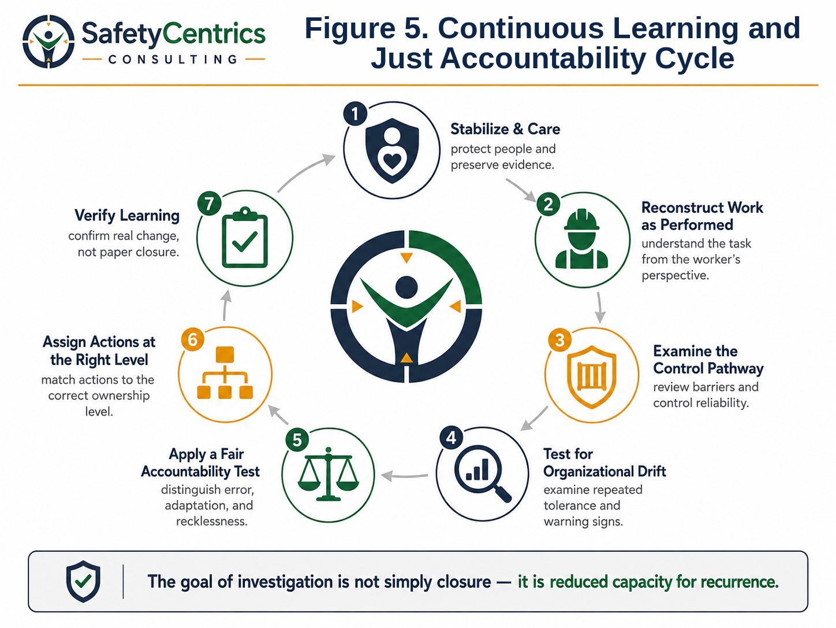
Figure 5. Continuous Learning and Just Accountability Cycle.

Stage 1 - Care, stabilize and preserve
Protect people, control residual risk, preserve evidence and support affected workers and families. Avoid premature conclusions.

Stage 2 - Reconstruct work as performed
Understand conditions, information, pressures, tools, local norms and the reasoning that made actions appear sensible at the time.

Stage 3 - Test the control pathway
Determine whether each critical control was defined, available, functional, understood, owned and verified.

Stage 4 - Examine organizational drift
Review prior incidents, near misses, defect history, audit findings, action extensions, staffing, overtime, production interruptions and workforce concerns.

Stage 5 - Apply fair accountability
Differentiate unintentional error, at-risk behavior, system-induced deviation, reckless behavior and malicious conduct using a structured just-accountability review of intent, risk awareness, system influence, and harmful purpose.

Stage 6 - Assign actions at the correct level
Place corrective actions with the role that has the authority, resources and technical ability to change the causal condition.

Stage 7 - Verify learning
Confirm that actual work changed, controls became reliable, similar exposures were reviewed and improvements remained effective over time.

8. Assigning Corrective Actions to the Right Level
A common indicator of a shallow investigation is that almost every recommendation is directed at workers or frontline supervisors. The action hierarchy below aligns findings with the level capable of changing them.
Finding | Primary ownership | Required response
Knowledge gap | Competency system owner and supervision | Verify task-specific capability; do not rely solely on attendance records.
Procedure does not reflect actual work | Operational process owner | Redesign with worker participation; validate in the field.
Critical control unavailable or unreliable | Engineering, maintenance, procurement and control owner | Restore reliability, define performance requirements and verify function.
Repeated shortcut accepted | Supervisory and operational leadership | Reset expectations, remove enabling conditions and increase field verification.
Production pressure conflicts with controls | Operational and executive leadership | Resolve priorities, capacity and scheduling; protect stop-work decisions.
Known material risk funding deferred | Senior leadership / governance | Reassess risk acceptance, interim controls and capital priority.
Previous action ineffective | Investigation governance and action owner | Reopen the finding, assess action quality and verify field effectiveness.
Deliberate reckless or malicious conduct | Individual and line management | Apply formal accountability consistently, while still examining system contributors.

9. Critical Controls and the Ownership of Verification
In mining and other high-hazard operations, the most important question is not whether a management system exists, but whether the controls relied upon to prevent fatalities and serious injuries are effective at the moment of exposure. ICMM's 2026 Critical Control Management guidance emphasizes leadership-driven safety culture and the prevention of critical-control failures (ICMM, 2026).
Every critical control should therefore have a named owner, a defined performance requirement, a verification method, an escalation threshold and a response when the control is unavailable or degraded. Workers may be required to confirm field conditions, but leadership retains accountability for the quality and availability of the control system.
An investigation should examine not only whether a control was absent, but whether the organization had falsely convinced itself that the control was healthy. A signed checklist is not proof of effectiveness. Verification must test the actual performance of the barrier.

10. Measuring Whether the Organization Has Learned
Organizations frequently measure investigation completion rather than learning effectiveness. Reports are issued, actions are entered into a database, training is delivered and procedures are revised. These activities demonstrate administration, not necessarily risk reduction.
HSE notes that in organizations that do not learn, later investigations often reveal a failure to implement earlier recommendations. Lessons must be communicated and recommendations implemented effectively, not simply recorded (HSE, 2024c).
Learning should be verified through leading evidence that work, controls and leadership behavior have changed.
- Field observations show the revised method is practical and consistently used.
- Critical-control verification demonstrates improved availability and performance.
- Workers can explain what changed, why it changed and when work must stop.
- Repeat deviations, defects and weak signals decline across comparable tasks.
- Supervisors intervene consistently and receive support when production is affected.
- Corrective actions remain effective after 30-, 60- and 90-day validation.
- Lessons are applied laterally to other sites, departments, contractors and similar hazards.
- Leaders can demonstrate which governance, resource or operating decisions changed as a result.

11. Application to Mining and High-Risk Operations
Mining operations combine mobile equipment, stored energy, ground instability, explosives, lifting, confined spaces, electrical systems, processing plants and contractor interfaces. Work is also shaped by remote locations, variable competency, production volatility, language and literacy differences, maintenance constraints and changing project phases. These conditions make simplistic worker-blame models especially ineffective.
The Shared Ownership Incident Learning Model should be integrated into serious-incident investigations, high-potential event reviews, critical-control failures and repeated low-level events. It should also be used before incidents occur through learning teams, field verifications and behavioral-drift reviews.
Leadership should expect every significant investigation to identify findings at multiple levels. A report that contains only worker and supervisor actions should trigger a quality review. Equally, a report that avoids clear individual accountability where conduct was demonstrably reckless should also be challenged. Mature learning requires honesty in both directions.

11.1 Recommended governance requirements
- Require an independent investigation leader for fatalities, serious injuries and high-potential events.
- Include operational, technical, worker and human-factors perspectives on the investigation team.
- Prohibit disciplinary conclusions until evidence collection and the fair-accountability review are complete, except where immediate protective action is necessary.
- Require explicit analysis of work as performed, critical controls, prior warning signs and behavioral drift.
- Assign at least one accountable executive sponsor for material organizational findings.
- Use action-quality criteria that favor engineering, design, capacity and control reliability over retraining alone.
- Verify actions in the field and report overdue or ineffective actions through operational governance.
- Share lessons in a manner that preserves dignity and does not turn harmed workers into warning posters.

12. Discussion: Who Ultimately Owns the Incident?
No single slogan can allocate accountability in every event. Yet one principle is reliable: the organization cannot claim ownership of safety before an incident and transfer ownership entirely to the worker after it.
If leaders own the culture, they own the tolerance embedded within it. If management owns the system, it owns the gaps between policy and practice. If operational leaders own production, they own the conflicts created when production expectations exceed safe capacity. If supervisors own field execution, they own the quality of task readiness and intervention. If workers own their choices, those choices must be judged within the conditions and information available to them.
The incident therefore belongs to the organizational system before it belongs exclusively to the individual. This is not a legal conclusion or an argument against personal responsibility. It is an operational learning principle. It ensures that the organization looks beyond the final action to the full chain of influence that made the event possible.

Conclusion
The person closest to an incident is often the easiest person to blame, but rarely the only person who owns the outcome. Organizations own the conditions they create, the pressures they apply, the controls they maintain, the deviations they tolerate and the lessons they fail to embed.
Workers remain accountable for decisions within their reasonable control. Deliberate recklessness, concealment and malicious conduct require clear consequences. But ordinary human error, at-risk behavior and system-induced deviation should lead first to understanding and correction. Punishment that ignores context may satisfy the immediate demand for accountability while preserving the conditions that will harm the next person.
A mature organization does not ask only who made the final mistake. It asks who designed the work, who controlled the risk, who observed the drift, who accepted the warning signs and who had the authority to intervene. It then assigns corrective action to each level of ownership.
The real measure of an investigation is not whether it identifies someone responsible. It is whether the organization becomes less capable of producing the same incident again.
Closing principle
Safety leadership becomes credible when leaders accept the same standard of ownership they expect from the workforce.

Appendix A - Incident Ownership and Learning Review Checklist
Review area | Quality question | Evidence / status
Event reconstruction | Have investigators reconstructed work as it was actually performed, including constraints, competing goals and local practices?
Immediate controls | Were all prevention and mitigation controls identified and their actual performance tested?
Individual context | Was the worker’s knowledge, intent, authority, available options and perception of risk examined?
Supervisory influence | Were planning quality, workload, task authorization, field presence and intervention considered?
Leadership influence | Were resources, priorities, production conflicts, maintenance decisions and risk acceptance examined?
Drift history | Was the duration, frequency, visibility and normalization of the deviation established?
Prior signals | Were related incidents, near misses, hazard reports, audits, defects and overdue actions reviewed?
Fair accountability | Was conduct classified using evidence of intent, risk awareness, available safe options, system influence, and organizational tolerance rather than by outcome severity alone?
Action level | Is each action assigned to the organizational level with authority to correct the causal condition?
Action quality | Do actions strengthen design, controls and capacity rather than defaulting to retraining and reminders?
Verification | Is there a defined method and date to confirm that work and risk changed in the field?
Lateral learning | Were equivalent risks across departments, contractors and sites assessed?
Comparable decision test | Would another competent person operating under the same conditions, information, and organizational expectations reasonably have made a similar decision?

References

Health and Safety Executive. (2004). Investigating accidents and incidents (HSG245). https://www.hse.gov.uk/pubns/hsg245.pdf
Health and Safety Executive. (2024a). Introduction to human factors. https://www.hse.gov.uk/humanfactors/introduction.htm
Health and Safety Executive. (2024b). Managing human failures: Overview. https://www.hse.gov.uk/humanfactors/topics/humanfail.htm
Health and Safety Executive. (2024c). Learning organisations. https://www.hse.gov.uk/humanfactors/topics/learning.htm
Health and Safety Executive. (n.d.-a). Human factors in accident investigations. https://www.hse.gov.uk/humanfactors/topics/investigation.htm
Health and Safety Executive. (n.d.-b). Behavioural safety and major accident hazards. https://www.hse.gov.uk/humanfactors/resources/behavioural-safety.htm
International Council on Mining and Metals. (2026). Critical Control Management: Good Practice Guide. https://www.icmm.com/en-gb/guidance/health-safety/2026/ccm-good-practice-guide
National Transportation Safety Board. (2014). Organizational factors in Metro-North Railroad accidents (SIR-14/04). https://www.ntsb.gov/safety/safety-studies/Documents/SIR1404.pdf
Occupational Safety and Health Administration. (2016). The importance of root cause analysis during incident investigation. https://www.osha.gov/sites/default/files/publications/OSHA3895.pdf
Occupational Safety and Health Administration. (n.d.). Incident investigation. https://www.osha.gov/incident-investigation

