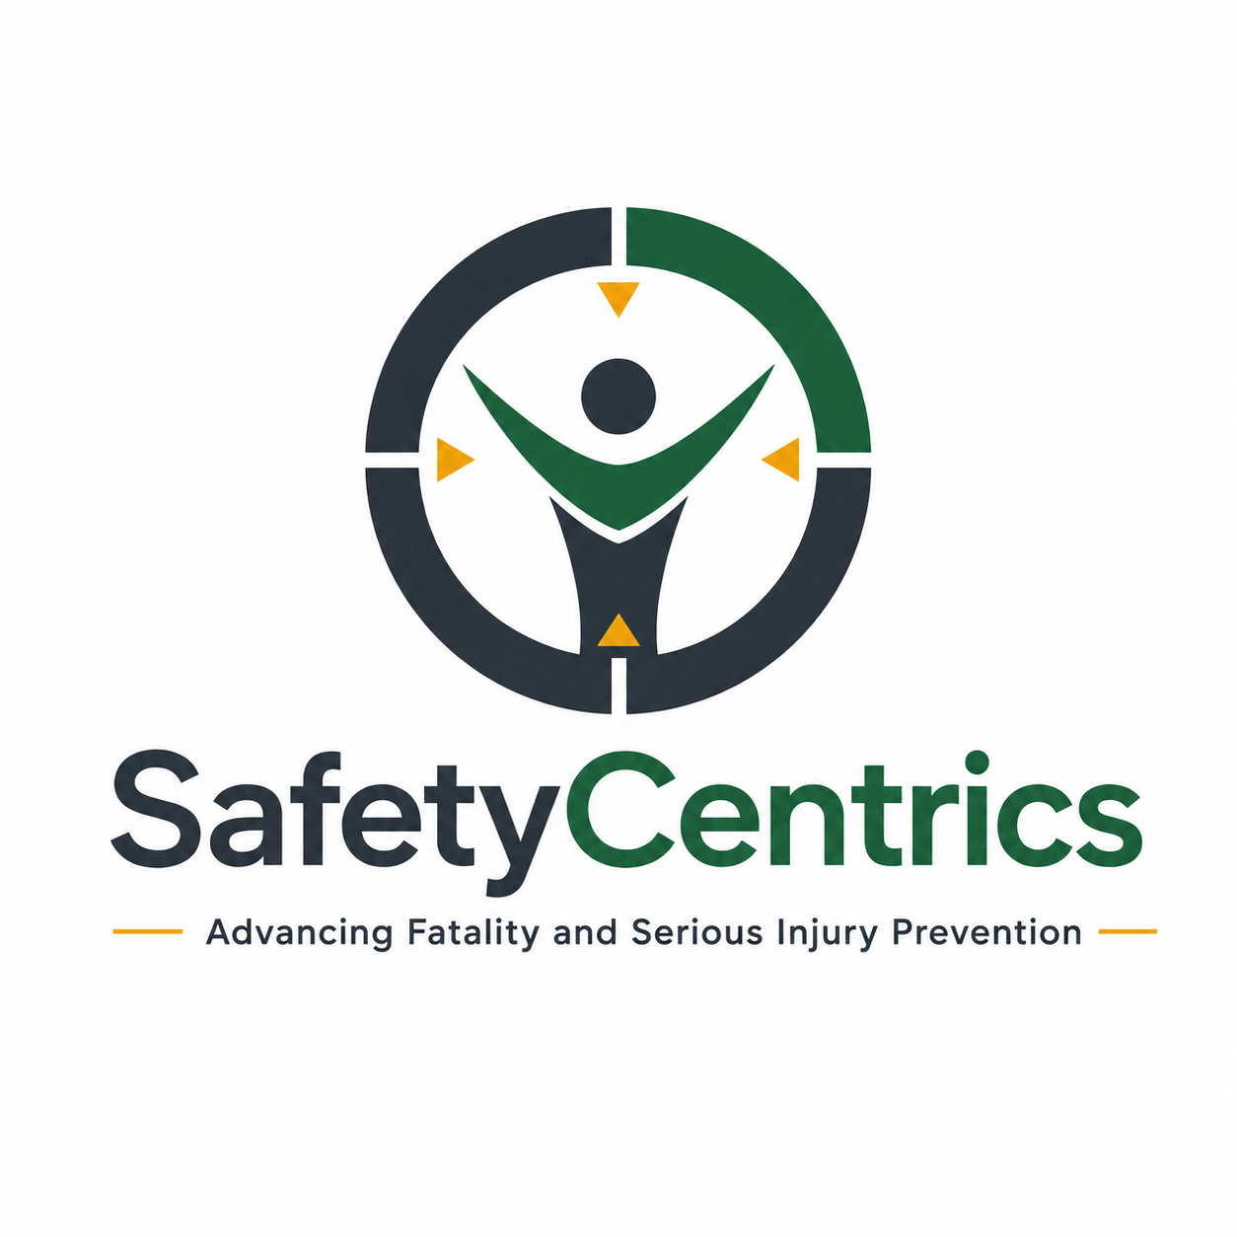
SAFETY CENTRICS CONSULTING
EXECUTIVE WHITE PAPER
WHAT DO WE MEAN
WHEN WE SAY SAFETY?
Understanding the Word, the Interpretation,
and the Organizational Reality
Safety is not proven by the absence of harm. It is demonstrated by the presence of protection.

James White
Safety Centrics Consulting
Organizational Character • Risk Intelligence • Critical Controls

Executive Summary
Few words appear more frequently in organizational language than safety. It is written into values, policies, procedures, leadership messages, training programs, performance reports, and workplace signs. Leaders declare that safety comes first. Supervisors tell people to work safely. Workers are expected to take responsibility for safety. Organizations measure safety, reward safety, investigate safety failures, and promote safety culture.
Yet the word itself is rarely examined. Safety can mean the absence of injury, compliance with rules, freedom from unacceptable risk, personal security, effective operational control, or simply a belief that nothing bad is likely to happen. These meanings overlap, but they are not the same. An organization can comply with rules and still expose people to poorly controlled fatal risk. People can feel safe because a hazardous task has been completed many times without consequence. Injury rates can remain low while critical controls deteriorate.
This paper argues that safety should not be treated as a slogan, a statistical outcome, or an abstract aspiration. Safety is a continually produced organizational condition. It exists when material risks are understood, necessary controls are present and effective, people can recognize and report change, and decisions protect life and health when cost, schedule, production, or reputation create competing pressure.
Because leaders, workers, contractors, regulators, and safety professionals may attach different meanings to the same word, organizations need a shared operational definition. The Safety Meaning Alignment Model developed in this paper tests four dimensions: what the organization declares, what it designs, what people experience, and what evidence demonstrates. Alignment across these dimensions makes safety credible. Misalignment creates the appearance of safety without reliable protection.
The true meaning of safety is not found in what an organization says. It is found in what people experience, what the organization controls, and what leaders protect under pressure.

Key Findings
- “Safety” is an umbrella term. Without a shared operational definition, different groups can act on different assumptions while believing they agree.
- The absence of injury is a result, not proof that risk was controlled. A favorable outcome may reflect sound protection, limited exposure, recovery capacity, or luck.
- Compliance establishes an important baseline, but compliance alone does not establish that critical risk is understood or controlled in the conditions actually encountered.
- Feeling safe and being protected are different states. Familiarity, normalization of deviation, production success, and previous luck can produce confidence without control.
- Safety becomes credible only when declared commitments, designed systems, lived experience, and demonstrated evidence align.
- Leadership decisions made under production, cost, and schedule pressure reveal the organization’s real definition of safety.
- A mature organization measures the presence and health of protective capacity, not only the historical absence of harm.

1. Introduction: The Most Used and Least Examined Word
Safety is one of the most powerful words in organizational life because it carries moral, legal, operational, and emotional weight. It implies care, responsibility, competence, and protection. It can reassure a workforce, authorize intervention, justify investment, and influence how society judges an organization.
Its power is also its weakness. Because the word is familiar, people assume its meaning is obvious. A chief executive, superintendent, supervisor, contractor, equipment operator, regulator, and family member may all hear “safety” and understand something different. The organization may still proceed as though the word created alignment.
The result is often a language of agreement without an agreement on reality. A leader may mean legal compliance. A safety professional may mean a functioning management system. A supervisor may mean completing work without an event. A worker may mean confidence that the equipment, plan, and team will not expose them to harm. A family may understand a promise that work will not take a life or permanently diminish one.
The central question is therefore not whether an organization values safety. Almost every organization says that it does. The more important questions are: What does safety mean here? How is that meaning translated into work? What evidence establishes that people are protected? What happens when the commitment is tested?

2. Defining Safety: Word, Condition, and Claim
At its simplest, safety is commonly understood as freedom from harm or danger. In occupational settings, however, absolute freedom from risk is rarely possible. Work involves energy, uncertainty, changing conditions, imperfect information, human adaptation, and technical systems that can fail. The practical objective cannot be a claim that risk no longer exists. It must be the creation and maintenance of sufficient protection against unacceptable harm.
ISO 45001 frames occupational health and safety management around preventing work-related injury and ill health, providing safe and healthy workplaces, eliminating hazards, minimizing risk, and continually improving performance. The International Labour Organization recognizes a safe and healthy working environment as a fundamental principle and right at work. These positions move safety beyond personal preference: it is both a managed organizational outcome and a human entitlement.
For operational purposes, this paper defines safety as follows:
Safety is a dynamic condition in which foreseeable sources of serious harm are recognized, exposure is controlled, people have the capacity and authority to respond to change, and the organization can prevent, absorb, or recover from failure without unacceptable human consequence.

This definition makes five points. Safety is dynamic, not permanently achieved. It concerns exposure as well as hazards. It requires effective controls rather than documented intentions. It recognizes that people need authority and capability, not merely instructions. It also includes the ability to respond when preventive systems do not behave as expected.

3. The Many Meanings Hidden Inside “Safety”
Meaning | What it emphasizes | What it can miss
Outcome | No injury or illness occurred. | Whether exposure was controlled or the result depended on luck.
Compliance | Rules, standards, and legal duties were met. | Novel conditions, weak execution, or risks beyond minimum requirements.
Feeling | People believe the situation is acceptable. | Bias created by familiarity, routine, trust, or previous success.
System | Processes exist to identify and manage risk. | Whether the system works at the point of exposure.
Control | Critical protections prevent or mitigate harmful energy. | Organizational pressures that weaken or bypass controls.
Value | Protection of people influences decisions. | Whether the stated value survives conflict with production or cost.
Performance | Indicators show acceptable results. | Low-frequency catastrophic risk and the condition of protective capacity.
Promise | The organization accepts a duty of care. | Whether resources, authority, and accountability support the promise.

Each meaning contributes something important. The failure occurs when one partial meaning is treated as the whole. An injury rate can describe outcomes but cannot, by itself, establish control effectiveness. A procedure can document a safe method but cannot establish that the work environment supports its use. A statement of values can communicate intent but cannot demonstrate what happens during conflict.

4. Safety Is Interpreted Through Position and Experience
People interpret safety through the demands, authority, information, and consequences attached to their roles. Executives often see aggregated information: trends, legal exposure, governance assurance, business continuity, and reputation. Frontline workers encounter immediate conditions: equipment state, ground conditions, isolation points, fatigue, supervision, workgroup capability, and pressure to proceed. Both perspectives are real, but they are not equivalent.
Perspective | Likely interpretation of safety
Board and executives | Governance, material risk, legal exposure, reputation, and continuity.
Operational leaders | Reliable work, controlled disruption, delivery, and resource decisions.
Supervisors | Planning, rule application, workforce coordination, and task completion.
Workers | Personal survival, dignity, trust, control availability, and returning home unharmed.
Contractors | Client expectations, site rules, commercial consequences, and permission to intervene.
Safety professionals | Risk systems, standards, learning, assurance, and control effectiveness.
Regulators | Compliance with statutory duties and minimum protections.
Families and communities | A moral expectation that work will not take or diminish a life.

Misalignment becomes dangerous when one group’s interpretation dominates. If executives equate low injury rates with safety, they may not ask whether critical controls are healthy. If supervisors equate safety with procedural compliance, they may treat deviation as a worker problem even when the plan could not be followed. If workers equate experience with competence, they may underestimate changing exposure. If contractors equate safety with avoiding client criticism, they may conceal uncertainty rather than disclose it.

5. The Absence of Harm Is Not the Presence of Safety
Organizations frequently use lagging outcomes as evidence that work is safe. Days without a recordable injury can be meaningful, but the conclusion drawn from them must remain disciplined. A period without injury shows that no recorded injury occurred during that period. It does not establish why.
The same outcome can arise from very different conditions: risk may have been effectively controlled; exposure may have been limited; workers may have compensated for weak systems; an initiating event may not have occurred; or the organization may simply have been fortunate. These possibilities have different implications for future performance.
Guidance on major-hazard performance measurement emphasizes the need for leading and lagging indicators that provide assurance over risk controls. That distinction matters because high-consequence events are infrequent. Waiting for the consequence to validate the weakness is not measurement; it is failure recognition.
A zero on an injury chart cannot tell leaders whether a critical control was available, effective, verified, and used at the moment it mattered.

This does not make outcome data irrelevant. It makes outcome data incomplete. Mature assurance combines outcome information with evidence about exposure, control health, work conditions, reporting quality, and the organization’s capacity to learn before loss.

6. Feeling Safe and Being Protected
Safety has both objective and subjective dimensions. People need confidence to work effectively, but confidence can develop independently of protection. Repetition without consequence creates familiarity. Familiarity can reduce the perceived significance of hazards. Informal adaptations can become normalized, especially when they help work continue and appear to produce successful results.
Conversely, workers may feel unsafe even when technical protections meet required standards. Their concern may reflect poor communication, limited trust, unfamiliarity, previous experience, or information that leaders have not considered. Dismissing that perception as irrational removes a potentially valuable signal.
The correct response is not to choose between perception and technical evidence. It is to investigate the relationship between them. If people feel safe, the organization should be able to identify the controls supporting that confidence. If people feel unsafe, leaders should understand what condition, uncertainty, or experience produces the concern.
Psychological safety is related but distinct. It concerns whether people believe they can speak, question, report mistakes, or raise concerns without interpersonal punishment. It does not mean that the physical work is safe. However, physical safety becomes much harder to maintain when people do not feel able to disclose uncertainty or interrupt work. Voice is therefore a protective capacity, not a substitute for engineering or operational controls.

7. Compliance, Systems, and the Point of Exposure
Compliance provides a necessary foundation. Laws, standards, procedures, training requirements, and documented accountabilities establish expectations and minimum controls. The danger lies in treating conformity as final proof of safety. A system may be complete on paper and weak where work occurs.
The point of exposure is where organizational meaning becomes physical reality. A policy does not isolate energy. A value statement does not prevent a vehicle interaction. A training record does not stabilize ground. A procedure does not verify atmospheric conditions. People are protected when the necessary controls are designed correctly, available, understood, applied, and effective in the conditions encountered.
Human factors guidance emphasizes that behavior is influenced by organizational, job, environmental, and individual conditions. This matters because “work safely” can never be a complete control strategy. The organization shapes choices through design, staffing, time, competence, supervision, incentives, maintenance, and the consequences attached to stopping or continuing work.

8. The Safety Meaning Alignment Model
A credible definition of safety must connect language to operational evidence. The Safety Meaning Alignment Model tests four dimensions.
Dimension | Central question | Evidence
1. Declared safety | What does the organization say it believes and expects? | Values, policies, standards, leadership messages, commitments, and stated accountabilities.
2. Designed safety | How has protection been built into work? | Engineering, task design, staffing, competence, planning, critical controls, maintenance, and emergency capacity.
3. Experienced safety | What do people actually encounter? | Production pressure, control availability, supervisory behavior, reporting confidence, fatigue, workarounds, and contractor treatment.
4. Demonstrated safety | What evidence shows protection is effective? | Control verification, exposure data, field observations, learning, assurance, response to weak signals, and leadership decisions.

Alignment exists when the same meaning survives across all four dimensions. A declared stop-work commitment, for example, should be supported by planned authority, adequate schedule contingency, respectful supervisory response, and evidence showing that interventions lead to learning rather than retaliation.
Misalignment creates recognizable patterns:
- Declared but not designed: leaders promise protection without providing resources, time, engineering, or competent staffing.
- Designed but not experienced: a technically sound system is undermined by unavailable controls, weak supervision, conflicting incentives, or contractor inequality.
- Experienced but not demonstrated: people believe conditions are safe, but the organization cannot verify control effectiveness.
- Demonstrated but not learned from: assurance identifies weaknesses, yet decisions, ownership, and follow-through do not change.
The model should not be used as a branding exercise. Its purpose is to expose contradictions. The strongest insight may come from the dimension that does not agree with the others.

9. Safety Through the Lens of Fatal and Serious Injury Prevention
The ambiguity surrounding safety becomes most consequential when fatal and serious injury potential is present. Minor-injury performance and catastrophic-risk control do not necessarily move together. An organization can improve housekeeping, personal protective equipment use, and low-severity event rates while leaving vehicle interactions, energy isolation, ground failure, lifting, fire, explosion, or work-at-height controls vulnerable.
FSI prevention requires a more precise question than “Are we safe?” It requires leaders to ask: What can kill or permanently harm a person here? What controls must never fail? What evidence shows those controls are functioning now? What changes could defeat them? Who can stop the work? What happens after that person does?
This is where safety moves from a general sentiment to risk intelligence. The organization identifies material exposure, names the critical controls, establishes performance requirements, verifies them in the field, and responds to weakness before the consequence provides undeniable proof.

10. Pressure Reveals the Real Definition
Organizational values are easiest to maintain when they cost little. The meaning of safety becomes visible when it competes with another objective. A delayed start, unavailable component, production shortfall, contractor claim, or executive commitment can turn an abstract value into a decision test.
If work continues with a known critical-control weakness because the schedule is important, the organization has defined safety as conditional. If a worker is praised publicly for intervention but penalized informally for delay, the organization has defined safety as symbolic. If leaders demand accurate reporting but react defensively to unfavorable information, the organization has defined safety as reputation management.
The organization’s real definition of safety is written in the trade-offs it accepts.

This does not mean that every concern requires indefinite shutdown. It means that decisions must be risk-informed, transparent, and consistent with predetermined control requirements. Commercial urgency cannot be allowed to silently redefine what the organization previously described as unacceptable.

11. From Safety Language to Safety Evidence
Organizations do not need to stop using the word safety. They need to make the word accountable. Every major safety claim should connect to observable evidence.
Common claim | Evidence-based reformulation
“Safety is our number one priority.” | We will not authorize work when defined critical controls are unavailable or ineffective.
“Everyone is responsible for safety.” | Leaders own system conditions; supervisors own work coordination; workers have defined authority to identify and interrupt exposure.
“Our site is safe.” | Material risks are known, critical controls meet performance requirements, and current assurance supports that conclusion.
“Workers can stop work.” | Interventions are tracked, supervisory responses are reviewed, and no adverse consequence is attached to a good-faith stop.
“Our performance is improving.” | Outcome trends, exposure information, control health, learning quality, and workforce experience show sustained improvement.

This shift changes safety from a declaration into a falsifiable claim. Leaders can ask what evidence would confirm the claim, what evidence would challenge it, and how quickly the organization would know if protection began to degrade.

12. The Leadership Safety Meaning Test
Leadership teams should answer the following questions independently, then compare their answers with those of supervisors, workers, and contractors:
- How does this organization define safety in operational terms?
- Would frontline workers and executives give substantially the same answer?
- What are the principal fatal and serious injury exposures in our current work?
- How do we know the controls for those exposures are effective today?
- Which indicators measure protection, and which merely report past outcomes?
- What conditions make it difficult for people to follow the intended work method?
- Can employees and contractors disclose uncertainty or stop work without personal consequence?
- What recent decision demonstrates that protection took precedence over production, schedule, cost, or reputation?
- Where do our declared commitments differ from the experience of work?
- What evidence would cause us to withdraw our claim that a task, site, or operation is safe?
Large differences in the answers are not a communication problem alone. They indicate that safety may not have a shared organizational meaning. The response should include dialogue, operational verification, and correction of system conditions—not another slogan.

13. A Practical Organizational Definition
Organizations should adopt a concise definition that is meaningful at every level. The following wording can be adapted to the organization’s risk profile:
In this organization, safety means that we understand the work and its potential for serious harm; provide and verify the controls needed to protect people; encourage the reporting of uncertainty and change; and stop or adapt work when protection cannot be assured.

The definition should then be translated into decision rules. What conditions prohibit work? Which controls are critical? Who verifies them? Who has authority to intervene? What response is required when a control is weak? What evidence reaches operational and executive leaders? Without these translations, even a strong definition remains language.

14. Discussion: Safety as Organizational Character
Safety is often discussed as a specialist function, cultural program, or performance stream. At its deepest level, it is evidence of organizational character. It shows how the organization treats knowledge, uncertainty, power, human fallibility, and competing interests.
An organization of strong character does not need perfect information to act responsibly. It remains curious about weak signals. It does not punish the messenger for revealing uncomfortable conditions. It distinguishes accountability from blame. It tests whether formal controls survive real work. It recognizes that workers adapt, but does not use human adaptability to compensate indefinitely for poor design.
This understanding also prevents safety from becoming detached from operations. Safety is not produced by the safety department and consumed by everyone else. It emerges from engineering, procurement, maintenance, staffing, scheduling, supervision, contracting, leadership, and the everyday decisions that shape exposure. Safety professionals can facilitate, challenge, assure, and advise, but operational leaders create many of the conditions that determine whether protection exists.

15. Conclusion: Safety Must Mean Something Observable
The word safety carries too much importance to remain undefined. When organizations use it loosely, people supply their own meanings. The result can be sincere commitment without shared understanding, impressive language without operational alignment, and strong historical statistics without reliable control of future harm.
Safety is not a permanent state that an organization achieves and possesses. It must be continually produced through the recognition of risk, design of work, availability of controls, capacity to speak and intervene, disciplined response to change, and leadership decisions that preserve protection under pressure.
The Safety Meaning Alignment Model offers a practical test. What is declared must be supported by what is designed. What is designed must survive what people experience. What people experience must be tested against what evidence demonstrates. Where the four dimensions disagree, the organization should not defend the word. It should correct the condition.
Safety is not established by declaring that it matters. It is established when no person must depend on silence, improvisation, or luck to complete work without harm.

References
Edmondson, A. C. (1999). Psychological safety and learning behavior in work teams. Administrative Science Quarterly, 44(2), 350–383. https://doi.org/10.2307/2666999
Health and Safety Executive. (2006). Developing process safety indicators: A step-by-step guide for chemical and major hazard industries (HSG254). HSE Books.
Health and Safety Executive. (2013). Managing for health and safety (HSG65). HSE Books.
Health and Safety Executive. (2024). Introduction to human factors. United Kingdom Health and Safety Executive.
International Labour Organization. (1981). Occupational Safety and Health Convention, 1981 (No. 155).
International Labour Organization. (2022). A safe and healthy working environment is a fundamental principle and right at work. ILO.
International Organization for Standardization. (2018). ISO 45001:2018: Occupational health and safety management systems—Requirements with guidance for use. ISO.
Reason, J. (1997). Managing the risks of organizational accidents. Ashgate.
Weick, K. E., & Sutcliffe, K. M. (2015). Managing the unexpected: Sustained performance in a complex world (3rd ed.). Jossey-Bass.

About the Author
James White is an international occupational health, safety, and operational risk leader with more than 25 years of experience across mining, construction, greenfield and brownfield projects, and complex operational environments. His work focuses on fatal and serious injury prevention, critical-control governance, behavioral alignment, organizational learning, and the translation of executive intent into field-level protection.

About Safety Centrics Consulting
Safety Centrics Consulting provides practical health, safety, risk, and operational assurance solutions across the project lifecycle. Its work helps organizations strengthen critical-risk governance, leadership visibility, workforce engagement, system integration, and the organizational conditions needed for sustainable performance.
Advancing Fatality and Serious Injury Prevention

