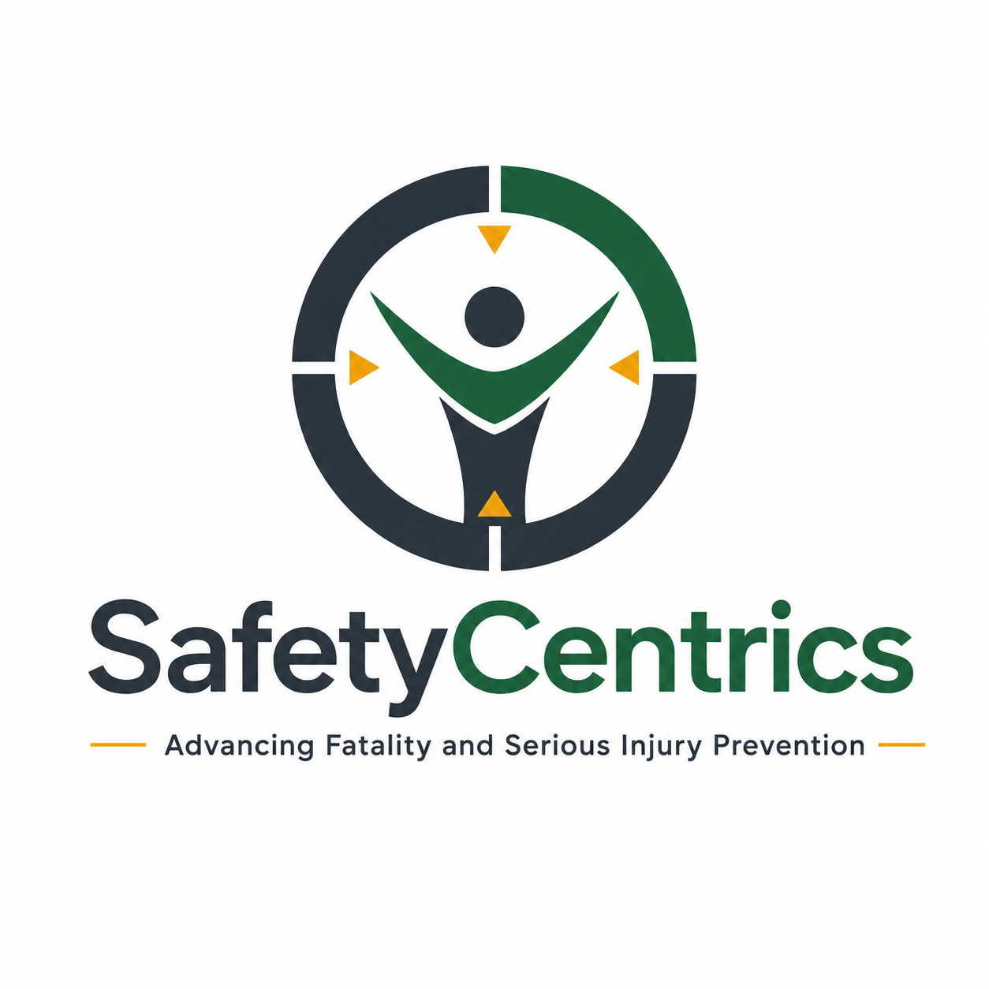
THE TRUE COST OF INCIDENTS
When Financial Recovery Replaces Organizational Learning
A White Paper on Insurance, Organizational Risk Retention, Behavioral Drift and Executive Accountability

James White
Safety Centrics Consulting
Advancing Fatality and Serious Injury Prevention

Executive Summary
Organizations are exceptionally good at measuring the visible financial consequences of incidents. Medical expenses, property loss, workers’ compensation, legal costs, business interruption and insurance recoveries can all be recorded, reserved and reported. Yet these numbers capture only part of the loss.
Insurance can transfer specified financial consequences. It cannot transfer the leadership decisions, weakened controls, normalized deviations, production pressures, cultural signals or behavioral drift that made the incident possible. Those conditions remain inside the organization unless leadership deliberately changes them.
This creates a governance risk: financial recovery can occur faster than organizational recovery. When a claim is settled, an asset is repaired and production resumes, leaders can receive powerful signals that the event has been contained even though the underlying risk pathway remains intact.
This paper proposes a broader incident-cost model based on four layers: insurable cost, operational cost, organizational cost and retained future risk. It introduces the Organizational Recovery Gap, the Incident Cost Transfer Model, Learning Return on Incident (LROI), and a verification-based definition of incident closure.
The central proposition is simple: insurance is a financial resilience mechanism, not a prevention strategy. A mature organization uses insurance to survive the consequence while using organizational learning to prevent recurrence.
Insurance can pay for yesterday’s incident. Only organizational change can reduce the probability of tomorrow’s.

Key Findings
Finding | Executive Implication
Financial recovery is not risk reduction. | Insurance can stabilize earnings and cash flow while the causal pathway remains unchanged.
Direct costs understate incident burden. | OSHA, NIOSH and ILO frameworks recognize substantial indirect and societal costs beyond compensation claims.
Closure can become administrative rather than operational. | Completing an action register is not evidence that behavior or critical-control performance changed.
Leadership response shapes future reporting and intervention. | Workers observe whether leaders seek learning, defend the system or assign blame.
The greatest retained liability may be recurrence potential. | Uncorrected behavioral and organizational conditions can silently rebuild exposure after the claim closes.

Contents
1. The Incident the Balance Sheet Cannot See
2. What an Incident Actually Costs
3. Financial Risk Transfer vs Risk Reduction
4. The Organizational Recovery Gap
5. Behavioral Debt and Operational Drift
6. Why Investigations Stop Too Early
7. The Executive Accountability Question
8. From Claims Management to Learning Management
9. Measuring the True Cost
10. Learning Return on Incident (LROI)
11. A Four-Stream Recovery Model
12. Redefining Incident Closure
13. Board-Level Questions
14. Recommendations
15. Conclusion
References

1. The Incident the Balance Sheet Cannot See
Following a significant workplace incident, organizations mobilize predictable processes: emergency response, medical care, regulatory notification, investigation, legal review, insurance notification, damage assessment and business-continuity planning. Eventually, executives may hear a reassuring phrase: “We are covered.”
Financially, that statement may be correct. Organizationally, it can be misleading. Insurance can reimburse specified property loss, medical expense, workers’ compensation, business interruption and liability. It cannot remove the operating conditions that created the event.
The central governance problem is therefore not insurance itself. Insurance is essential. The problem emerges when financial risk transfer becomes confused with operational risk reduction.
Financial stabilization and organizational stabilization are not the same thing.
The appropriate executive question is not merely whether the company can absorb or transfer the financial loss. It is whether the organization has changed the conditions capable of producing the same event again.

2. What an Incident Actually Costs
Traditional incident accounting focuses on measurable loss: treatment expenses, workers’ compensation, damaged assets, legal expenses, deductibles, settlements and production interruption. These are real costs, but authoritative occupational-safety sources explicitly recognize that incident cost extends well beyond the claim.
OSHA identifies indirect costs such as training replacement employees, investigating incidents, implementing corrective measures, lost productivity, repair of damaged equipment and property, lower employee morale and absenteeism. NIOSH mining tools similarly distinguish direct workers’ compensation cost from indirect costs associated with occupational injury. The ILO has estimated the broader economic burden of occupational injury and disease at about 3.94% of global GDP.
For executive purposes, incident cost is better understood through four layers: insurable cost, uninsured operational cost, organizational cost and retained future risk.
- Insurable cost: medical expense, compensation, property loss, specified liability and business interruption.
- Operational cost: downtime, investigation, replacement labour, overtime, schedule disruption, retraining and leadership time.
- Organizational cost: trust, morale, leadership credibility, reputation, retention, regulatory confidence and workforce engagement.
- Retained future risk: behavioral drift, normalized deviation, degraded critical controls, production pressure and recurrence potential.
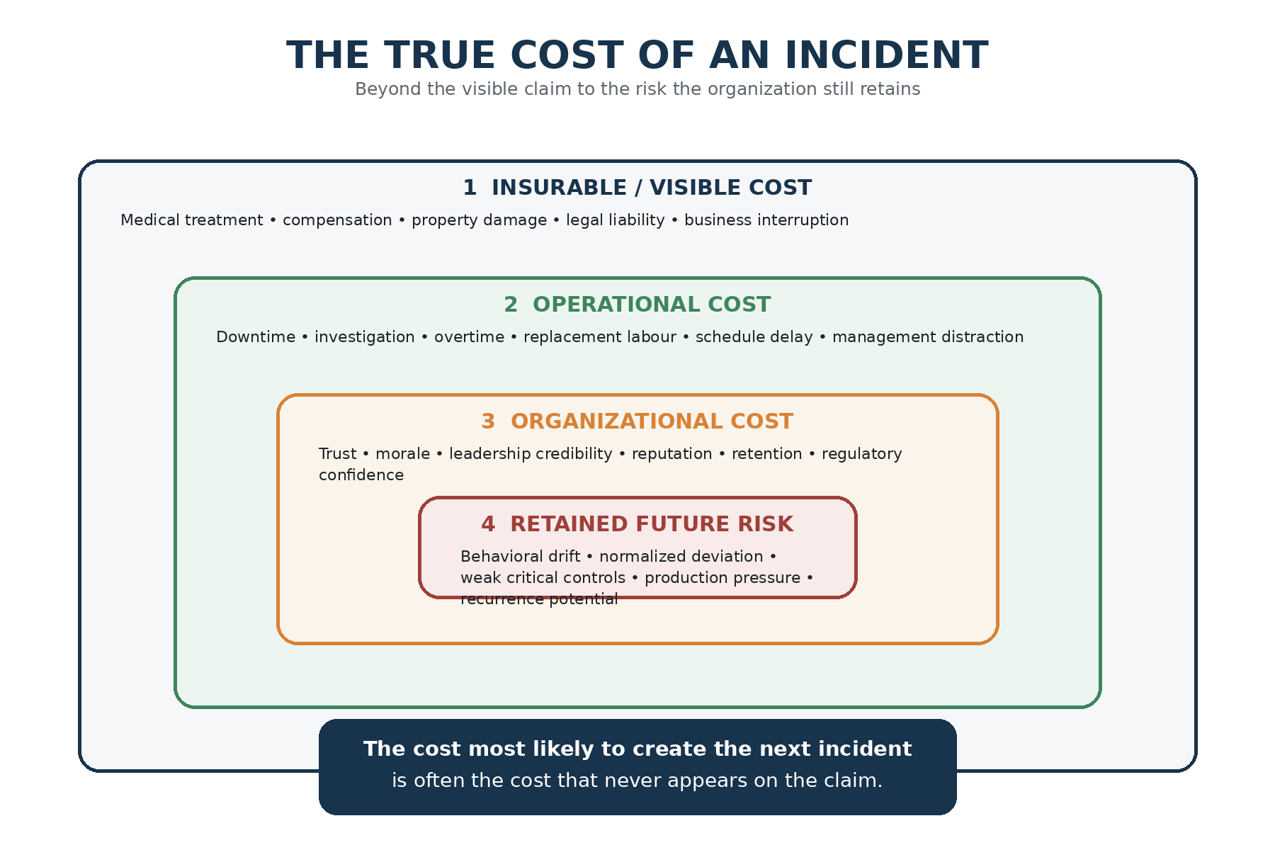
Figure 1. The True Cost of an Incident — a four-layer model distinguishing visible loss from retained future risk.

3. Financial Risk Transfer vs Risk Reduction
Insurance is a mechanism for financing consequence. Prevention operates upstream. It changes the probability that hazardous conditions develop into serious events and the severity that follows when they do.
This distinction is especially important in high-hazard industries. ICMM’s 2026 Critical Control Management guidance emphasizes leadership-driven safety culture and the reliable management of critical controls to prevent fatal outcomes. ISO 45001 likewise places leadership commitment, worker participation, hazard identification, operational control, performance evaluation and continual improvement at the center of occupational health and safety management.
A sophisticated insurance program can therefore coexist with weak operational learning. The existence of one says little about the quality of the other.
Insurance protects the balance sheet from consequence. Critical controls protect people and operations from the event.
The risk is not that executives consciously prefer claims over prevention. The risk is that a successful financial recovery process can create a perception of closure before the organization has demonstrated meaningful behavioral or systemic change.
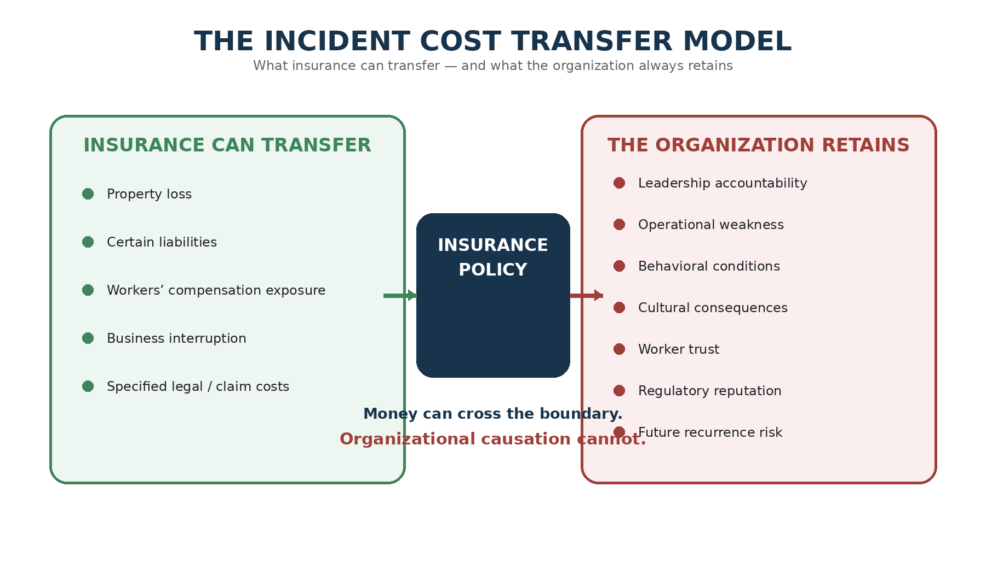
Figure 2. The Incident Cost Transfer Model — financial consequences may be transferred; organizational causation remains.

4. The Organizational Recovery Gap
An insurer may settle a claim months before a company can demonstrate that its culture, leadership behaviors and critical-control performance have changed. This creates the Organizational Recovery Gap: the period during which financial recovery has advanced faster than organizational recovery.
The gap is dangerous because visible indicators of normality return first. The asset is repaired. Production restarts. Financial reserves stabilize. External scrutiny declines. Corrective actions move toward closure. Yet the less visible work — rebuilding trust, testing new controls, challenging production incentives, assessing similar exposures and verifying changed behavior — takes longer.
Organizations are most vulnerable when they interpret the return of normal operations as evidence of reduced risk.
If the pre-incident operating state helped create the event, returning to “normal” is not recovery.
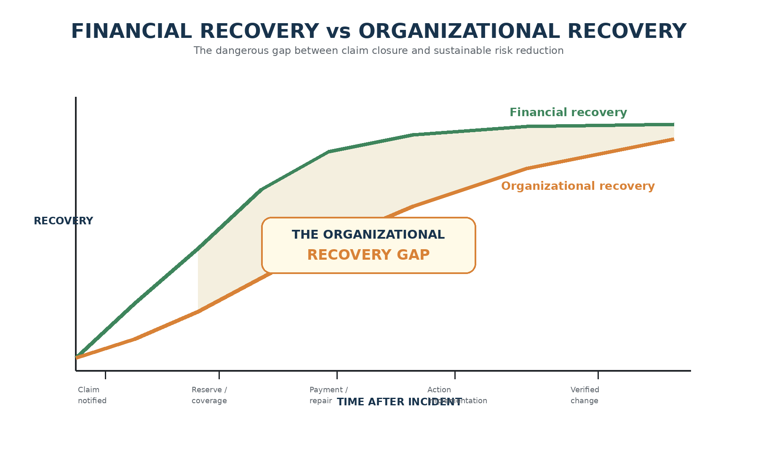
Figure 3. Financial Recovery versus Organizational Recovery — the Organizational Recovery Gap persists after visible financial stabilization.

5. Behavioral Debt and Operational Drift
Catastrophic events rarely begin catastrophically. They develop through small adaptations that become normal: a verification performed from memory rather than at the point of work; a recurring defect tolerated until the next shutdown; a shortcut accepted to protect production; a hazard report that receives no meaningful response; a temporary workaround that quietly becomes permanent.
Each successful deviation teaches the organization something dangerous: that the control may not really be necessary. This creates behavioral debt. Nothing appears on the balance sheet, but exposure accumulates.
Operational drift becomes especially difficult to detect because the people closest to the work adapt gradually. The organization does not vote to accept more risk. It arrives there through repeated exceptions that stop feeling exceptional.
Insurance cannot interrupt this process. Leadership presence, worker participation, critical-control verification, meaningful reporting and disciplined learning can.

6. Why Investigations Stop Too Early
Many investigations identify immediate and contributing causes but fail to follow the causal pathway into organizational behavior. A worker bypassed a procedure. A supervisor did not verify a control. A maintenance task was rushed. These may all be true, but they are not necessarily complete explanations.
The deeper questions are: Why was the deviation rational in that operating environment? What pressures shaped the decision? What previous successes normalized the shortcut? What did leaders ask for, reward or tolerate? What warnings had already been available?
An investigation that stops at the person closest to the event can achieve administrative closure while leaving organizational causation untouched.
ISO 45001 explicitly integrates incident investigation with leadership, worker participation and continual improvement. ICMM’s fatality-prevention approach similarly emphasizes reliable critical controls rather than reliance solely on procedures or individual behavior.
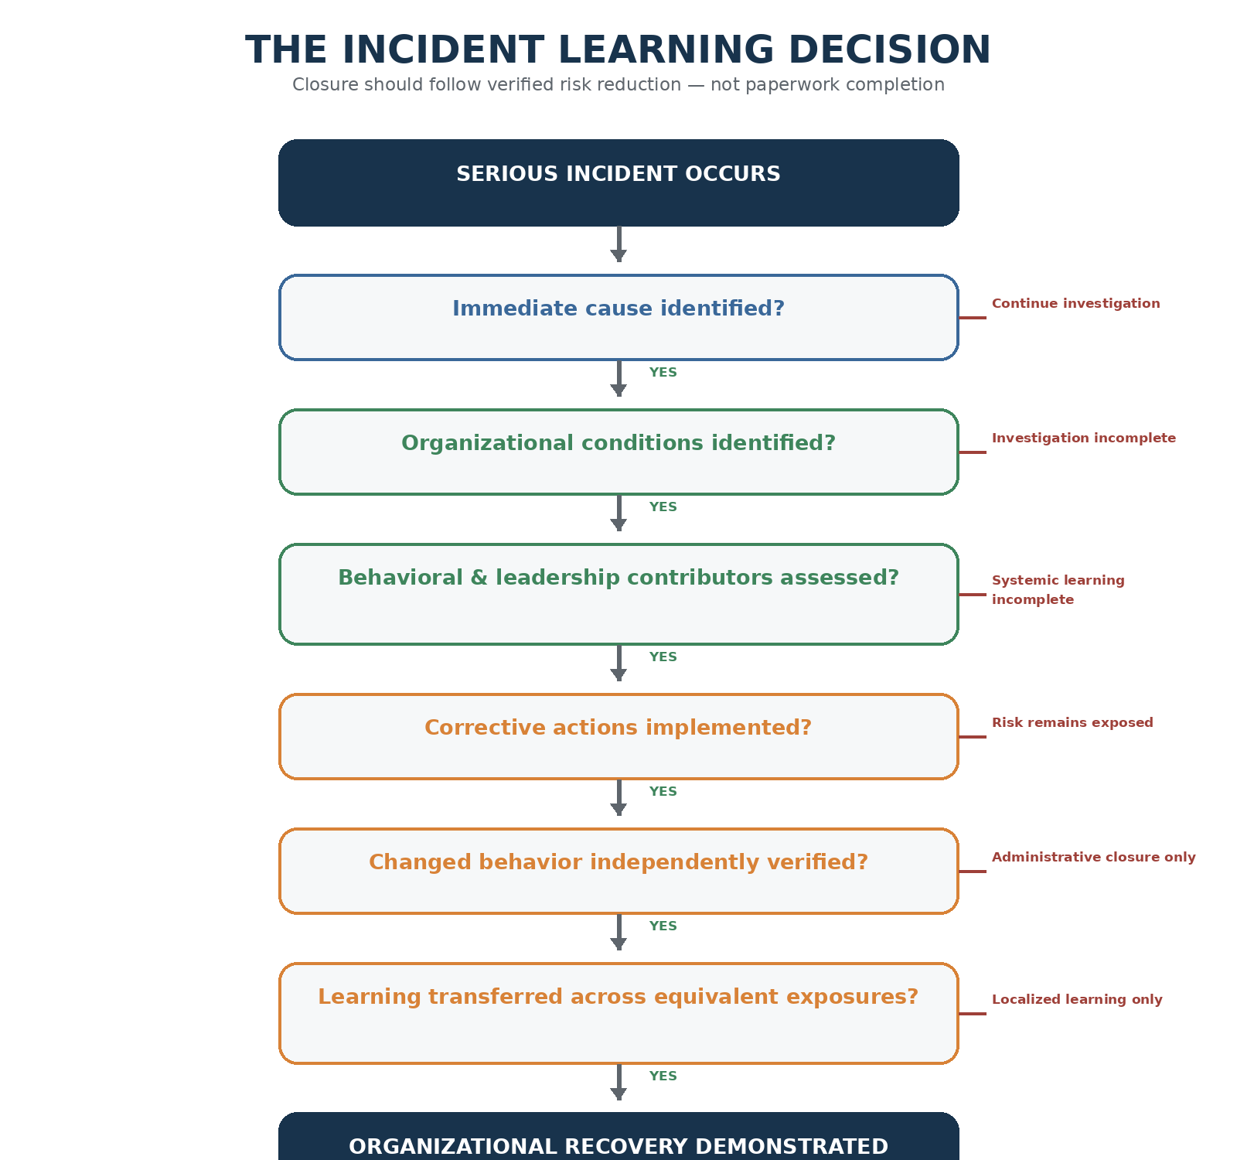
Figure 4. The Incident Learning Decision — investigation closure should follow verified risk reduction and enterprise learning.

7. The Executive Accountability Question
After every fatality, serious injury or high-potential event, executives and boards should ask a deliberately uncomfortable question: What did we know before the event?
Were similar near misses reported? Had audits identified weaknesses? Were controls routinely bypassed? Were corrective actions overdue? Did workers raise concerns? Did production conditions create pressure? Were supervisors managing conflicting priorities?
If the organization possessed warning signals before the incident, the governance issue shifts. The event may not have been unforeseeable; it may have been an unmanaged warning.
The question is no longer only “Why did the worker do this?” It becomes “Why did the organization allow the conditions supporting this decision to persist?”

8. From Claims Management to Learning Management
Organizations often have highly mature claims-management processes. Serious incidents require an equally disciplined learning-management process.
A claim file answers financial questions. A learning file should answer organizational ones: what changed, how it was verified, whether similar exposures were examined elsewhere, whether leadership behavior shifted, whether workers trust reporting more, and whether critical controls now perform differently in the field.
This distinction protects the legitimate role of insurance while preventing claim closure from becoming a substitute for risk closure.

9. Measuring the True Cost
The true incident cost can be expressed conceptually as:
True Incident Cost = Direct Financial Loss + Uninsured Operational Loss + Human Consequence + Organizational Damage + Strategic Exposure + Retained Future Risk
The final term is the least visible and potentially the most important. Retained future risk represents the exposure that remains because the organization has not yet converted incident learning into verified change.
OSHA’s Safety Pays framework reinforces the wider financial argument by using indirect-cost multipliers and profit margin to estimate the additional sales an employer may need to generate to cover injury costs. The business effect therefore extends beyond the value of the compensation claim itself.

10. Learning Return on Incident (LROI)
Every serious event generates information at extraordinary human and financial cost. The organization should therefore evaluate whether it converted that information into measurable risk reduction.
Learning Return on Incident (LROI) is proposed as a governance concept rather than a financial ratio. It asks whether the organization became demonstrably stronger because of what it learned.
- Did critical-control verification improve in quality, not merely frequency?
- Did reporting confidence and intervention increase?
- Did leadership field engagement change?
- Were production and reward signals reviewed?
- Were equivalent exposures tested across other sites and contractors?
- Were corrective actions verified after implementation?
- Could the same causal pathway still exist somewhere else in the enterprise?
If the final answer remains yes, the learning process is incomplete regardless of whether the claim, investigation or action register has been administratively closed.

11. A Four-Stream Recovery Model
Serious incidents should trigger four parallel recovery streams. Human recovery addresses treatment, rehabilitation, family support and workforce care. Operational recovery stabilizes work and confirms safe restart conditions. Financial recovery manages claims, liabilities, asset replacement and business continuity. Organizational recovery addresses leadership behavior, culture, incentives, critical-control performance, worker trust and enterprise learning.
The organization should not declare full recovery because one stream — usually financial or operational — has progressed faster than the others.
Human Recovery | Operational Recovery | Financial Recovery | Organizational Recovery
Medical care | Secure area | Insurance notice | Leadership review
Rehabilitation | Restart criteria | Claim management | Behavioral analysis
Family support | Similar exposure review | Liability / reserve | Control verification
Workforce support | Safe production recovery | Asset replacement | Cultural learning
Psychological support | Operational assurance | Business continuity | Enterprise transfer

12. Redefining Incident Closure
A closed claim is a financial status. A closed regulatory file is a legal status. A closed corrective action is an administrative status. None automatically demonstrates that risk has been reduced.
A defensible incident-closure standard should require evidence that immediate hazards are controlled, systemic causes are addressed, leadership contributors are examined, critical controls are effective, behavioral change is verified, similar exposures are assessed and learning has transferred across the enterprise.
This changes closure from a paperwork milestone into a risk-performance milestone.
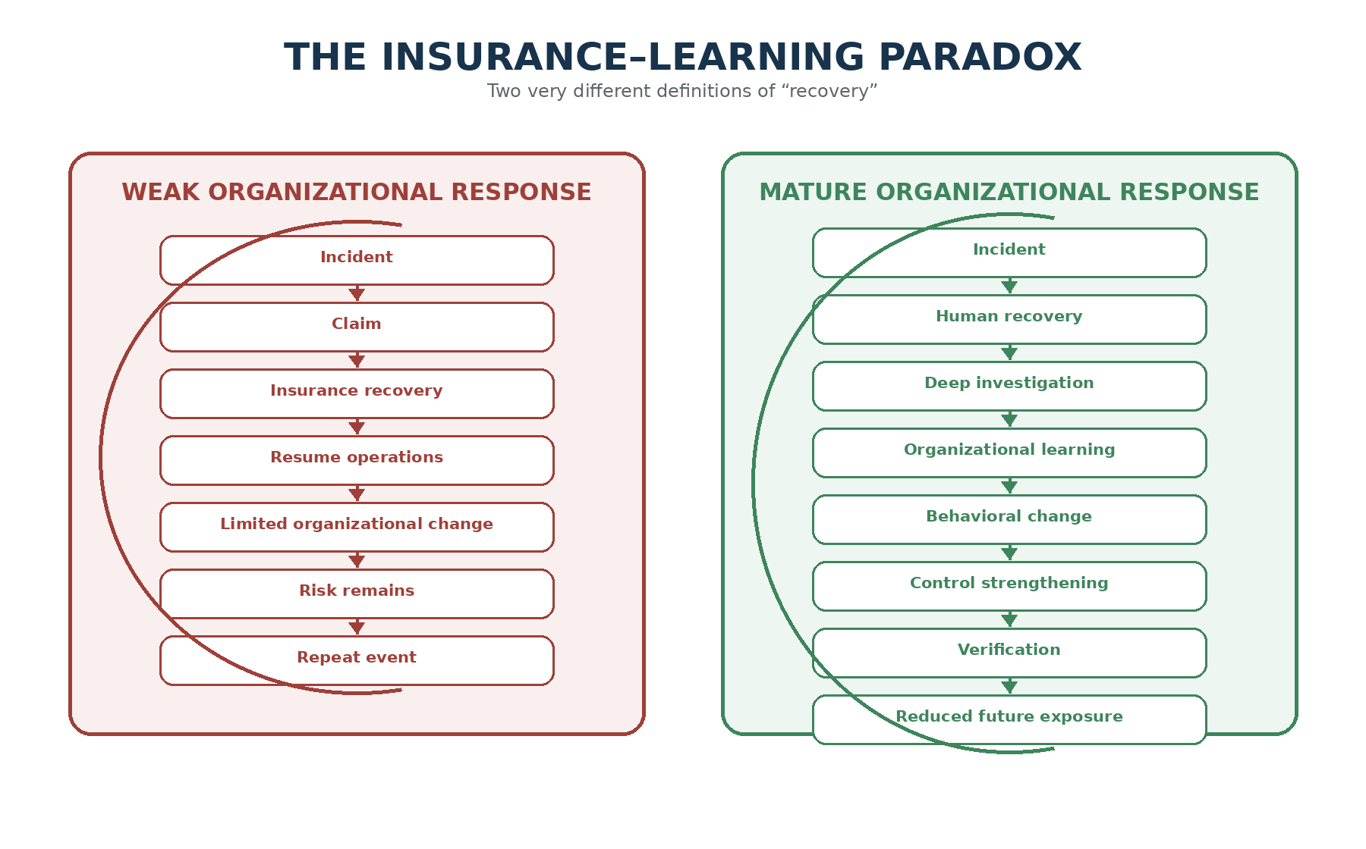
Figure 5. The Insurance–Learning Paradox — financial recovery may complete while risk remains, or the incident can become a catalyst for verified organizational learning.

13. Board-Level Questions
Boards and executive committees should receive more than injury rates, claim values and action-closure percentages. Following any fatality, serious injury or high-potential event, governance review should test the quality of learning.
- What did the organization know before the event?
- What warnings, near misses, audit findings or overdue actions existed?
- Which critical controls should have prevented or mitigated the event?
- How and why did those controls degrade?
- What organizational pressures influenced operational decisions?
- What did frontline workers understand that leadership did not?
- What leadership behaviors may have reinforced the exposure?
- What evidence demonstrates that behavior and control performance have changed?
- Where else could the same causal pathway exist?
- What independent verification will confirm sustainable change?

14. Recommendations
Organizations seeking to reduce the gap between financial recovery and organizational recovery should adopt the following practices:
- Separate claim closure from incident-risk closure in governance reporting.
- Report the four layers of incident cost, including organizational and retained-risk consequences.
- Require executive review of pre-incident warning signals and known control weaknesses.
- Assess behavioral and leadership contributors alongside technical causes.
- Verify corrective-action effectiveness in the field after implementation.
- Use serious events to test equivalent exposures across the enterprise, not only the affected site.
- Add LROI-style questions to board and executive incident reviews.
- Measure critical-control quality and worker reporting confidence as leading indicators of recovery.
- Treat insurance as financial resilience, never as evidence that the underlying risk has been controlled.

15. Conclusion — You Cannot Insure Your Way to Organizational Maturity
Insurance is essential to corporate resilience. It allows organizations to absorb volatility, protect capital and recover from significant financial loss. But its success should never be confused with prevention.
Insurance can rebuild an asset. It cannot rebuild trust automatically. It can compensate defined loss. It cannot remove behavioral drift. It can protect the balance sheet. It cannot repair weak leadership signals, normalized deviation or ineffective critical controls unless the organization deliberately acts on what the incident revealed.
The true measure of recovery is therefore not the settlement date, the restart date or the percentage of actions marked complete. It is whether the organization can demonstrate that the causal conditions no longer exist and that equivalent exposures have been addressed elsewhere.
The most expensive incident is not necessarily the one with the largest claim. It is the one from which the organization learns nothing.
An insurance settlement can close the financial chapter of an incident. Only verified organizational change can close the risk chapter.

References
International Council on Mining and Metals (ICMM). (2026). Critical Control Management: Good Practice Guide. Published 28 April 2026.
International Council on Mining and Metals (ICMM). (2026). Benchmarking Progress of ICMM Company Members in 2025 / 2025 Safety Performance. Published 30 July 2026.
International Organization for Standardization (ISO). (2018; web explanation updated 2026). ISO 45001:2018 — Occupational health and safety management systems — Requirements with guidance for use.
International Labour Organization (ILO). Occupational Safety and Health guidance and economic-cost estimates; global economic burden of work-related fatal and non-fatal injuries and illnesses estimated at 3.94% of global GDP.
National Institute for Occupational Safety and Health (NIOSH). Safety Pays in Mining: User’s Guide and Technical Guide. Updated 20 October 2023.
National Institute for Occupational Safety and Health (NIOSH). Fatalities Cost in Mining Web App. Updated 6 January 2025.
Occupational Safety and Health Administration (OSHA). Business Case for Safety and Health — Costs.
Occupational Safety and Health Administration (OSHA). Safety Pays Individual Injury Estimator and Background of Cost Estimates.

Author Note
This paper is intended as a professional discussion of organizational learning, operational risk and executive governance. Insurance coverage, legal liability and regulatory obligations vary by jurisdiction and policy; organizations should obtain appropriate legal, insurance and risk-management advice for specific events.

