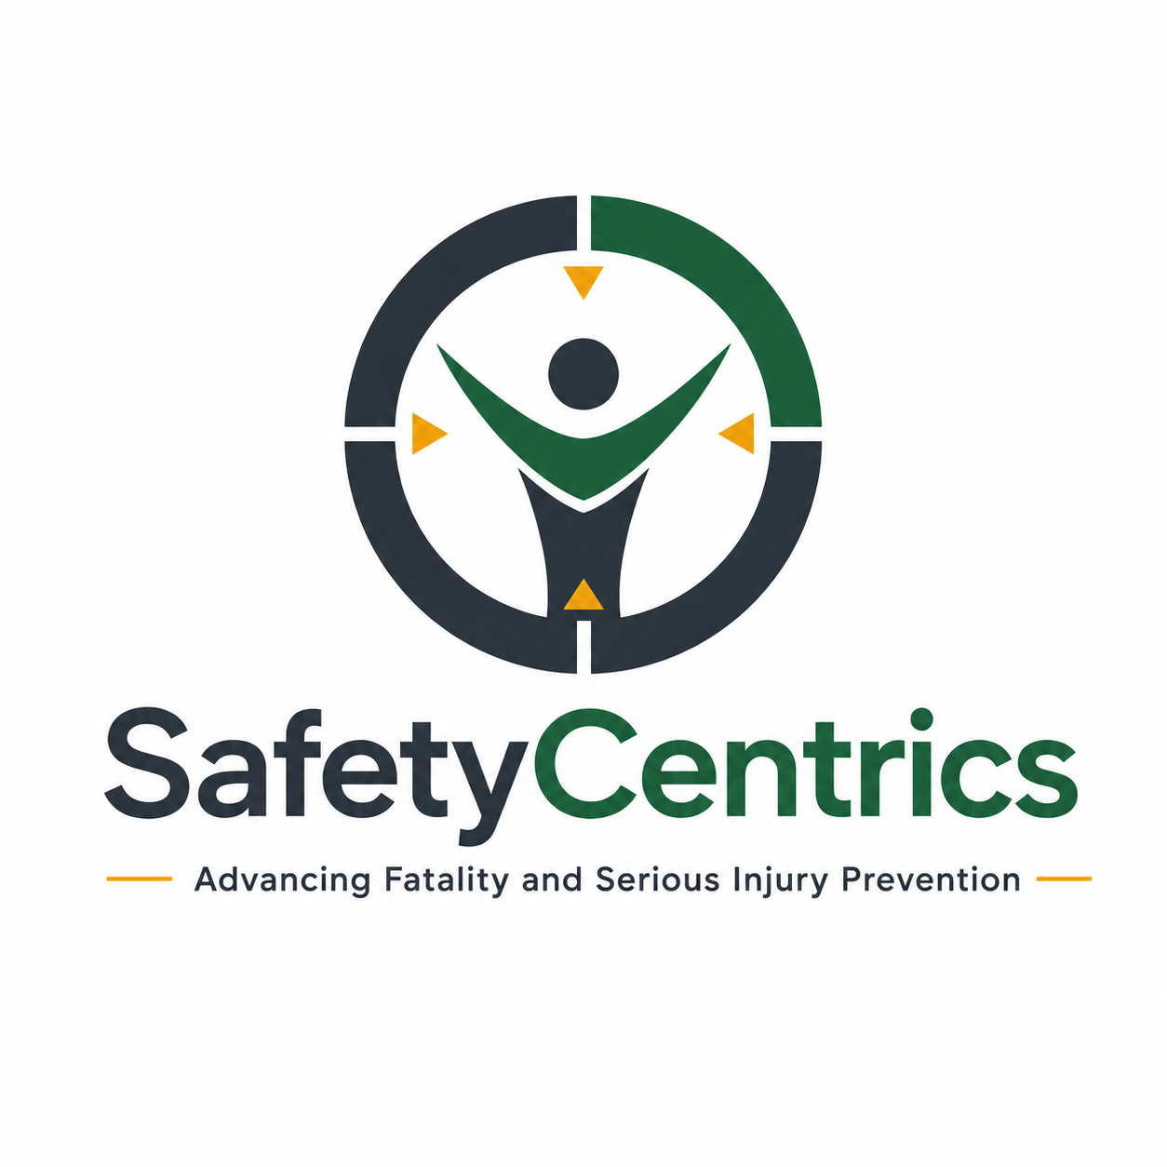
THERE IS NO SUCH THING AS SAFETY CULTURE
Reframing Safety as an Outcome of Organizational Character
An Executive White Paper on Organizational Culture, Behavioral Design,
Critical Controls and Leadership Accountability
James White
Safety Centrics Consulting
Advancing Fatality and Serious Injury Prevention

Executive Summary
For more than three decades, the term safety culture has become embedded within occupational health and safety practice, regulatory guidance, management systems, leadership programs and incident analysis. Its importance is well established. This paper does not argue that the extensive body of safety-culture research is without value. Rather, it challenges the way organizations frequently interpret and operationalize the concept. The central proposition is that safety is not an independent culture existing alongside production, maintenance, engineering, quality, finance or human resources. Safety is an expression of the broader organizational culture from which decisions and behaviors emerge.
An organization has one underlying organizational character. That character influences what leaders reward, what supervisors tolerate, how employees respond to uncertainty, whether concerns can travel upward, how resources are allocated, how operational pressures are resolved and whether critical controls remain effective when business priorities compete.
Safety is not separate from organizational performance. Safety is evidence of organizational performance.

Key Findings
Finding | Executive Implication
Safety culture is not organizationally separate. | Safety performance reflects the broader culture that shapes decisions, incentives, trust, work design and control discipline.
Safety is produced upstream. | Leadership beliefs, organizational conditions and operational decisions influence behavior before an injury outcome is visible.
Low injury rates do not prove low serious-risk exposure. | Critical-control integrity and weak-signal detection provide stronger insight into FSI potential than lagging frequency alone.
Behavioral drift is an organizational signal. | Repeated deviation may indicate adaptation to pressure, weak supervision, poor work design or controls that no longer fit operational reality.
Culture is tested under pressure. | The organization’s true character appears when production, schedule, cost or authority conflicts with control integrity.

Contents
1. Introduction
2. What Do We Mean by Culture?
3. The Safety-Culture Construct
4. There Is Only One Organization
5. Safety Is an Outcome, Not a Behavior
6. Organizational Accidents and Latent Conditions
7. Organizational Character
8. The Moment of Truth
9. Safety as a Priority Is Structurally Weak
10. Safe Behavior by Design
11. Behavioral Drift and the Normalization of Deviance
12. Safety Performance and Lagging Indicators
13. Critical Controls Are Cultural Tests
14. High Reliability and Organizational Mindfulness
15. The False Divide Between Safety and Production
16. Safety Is Not Owned by the Safety Department
17. From Safety Management to Risk Intelligence
18. Organizational Character-to-Outcome Model
19. The Leadership Culture Test
20. What Should Replace Safety Culture?
21. Discussion
22. Conclusion
References

1. Introduction
The term “safety culture” is now deeply embedded in occupational health and safety. Organizations seek to build it, consultants assess it, safety professionals measure it, and incident investigations frequently identify weaknesses within it.
The concept has a legitimate history. Following the 1986 Chernobyl disaster, international nuclear-safety work elevated attention to the organizational attitudes and behaviors that shape safety. Later research explored safety culture and safety climate as ways to understand the relationship between organizational systems, management commitment, shared assumptions and behavior.
Those contributions remain valuable. They also raise a harder question: if safety culture is a component or expression of organizational culture, have organizations gradually mistaken the component for the whole?
If safety performance is understood as an expression of organizational culture, the inquiry moves upstream from campaigns and slogans to the organizational conditions that create behavior.

2. What Do We Mean by Culture?
Organizational culture is reflected in the shared assumptions, beliefs, expectations and unwritten rules that influence how people behave. It operates below formal policies and stated values. Employees learn culture through repeated experience: what matters, what is rewarded, what is ignored, who can challenge whom, what happens when targets are missed, and which rules become negotiable under pressure.
Policies describe intent. Culture reveals reality. A company may declare that people come first, but that value becomes meaningful only when protecting people carries an operational or financial consequence.
Culture is not what an organization says. Culture is what an organization repeatedly demonstrates.

3. The Safety-Culture Construct
The safety-culture construct should not be dismissed. It has helped organizations move beyond purely technical explanations of accidents and toward leadership, behavior, systems and organizational learning. Guldenmund reviewed the theoretical foundations of safety culture and safety climate, while Cooper described safety culture as a sub-facet of organizational culture and linked psychological, behavioral and situational dimensions.
The position advanced here is therefore not that safety culture is fictitious. It is that safety culture is more usefully understood as the safety-related expression of organizational culture than as a parallel culture operating independently within the enterprise.
The issue is not whether culture influences safety. It clearly does. The issue is where organizational responsibility for that influence begins.

4. There Is Only One Organization
Consider a site where employees routinely bypass a procedure to maintain output. Calling this a “poor safety culture” may be descriptively convenient, but it does not identify the mechanism creating the behavior.
The deeper causes may include unrealistic production expectations, conflicting incentives, weak supervision, poor equipment availability, normalization of deviation, ineffective critical controls, low confidence in management or procedures that no longer reflect the work.
These are organizational problems producing safety consequences. The diagnosis matters because the way a problem is named determines where the organization looks for its solution.
There is no separate safety organization operating inside the business. There is one organization, and its culture expresses itself through every business outcome.

5. Safety Is an Outcome, Not a Behavior
A worker cannot simply “do safety.” A worker can isolate energy, verify ground conditions, maintain separation, follow a lifting plan, challenge an unsafe instruction, stop work, reassess risk or verify a critical control. A supervisor can plan work, allocate competent people, verify controls and respond constructively to concerns. A leader can establish realistic expectations, allocate resources, reward transparency and refuse to trade control integrity for short-term output.
These are observable actions. Safety is one of their intended consequences.
Organizational beliefs → leadership expectations → systems and incentives → operational conditions → decisions → behaviors → control effectiveness → outcomes.

6. Organizational Accidents and Latent Conditions
James Reason’s work on organizational accidents demonstrated why serious events cannot be adequately understood by focusing solely on the frontline act closest to the consequence. Conditions created through design, management and organizational decisions can exist long before they combine with local circumstances and active failures.
An apparently unsafe frontline decision may sit downstream from poor equipment design, inadequate staffing, conflicting priorities, ineffective supervision, procedural complexity, production pressure, weak maintenance or inaccessible controls.
Human behavior therefore cannot be meaningfully separated from the environment in which it occurs.
If organizations create the conditions that influence behavior, safety performance cannot be delegated primarily to the people exposed to those conditions.

7. Organizational Character
The term organizational character provides a useful extension of safety-culture thinking. Organizational values describe what the company says it believes. Organizational character describes what it repeatedly demonstrates.
Character becomes visible when values become inconvenient: when a control failure threatens production, when an employee challenges a senior leader, when an investigation implicates management decisions, or when the safer option requires more time and money.
Who does the organization become when circumstances are difficult? That is the cultural question.

8. The Moment of Truth
Most organizations can demonstrate strong values when operations are stable. The more meaningful test occurs when safe execution competes with another organizational objective.
The moment of truth occurs when production conflicts with control integrity, schedule conflicts with planning quality, cost conflicts with engineering robustness, authority conflicts with challenge, reputation conflicts with transparency, or accountability conflicts with organizational self-protection.
What happens when doing the right thing becomes operationally inconvenient?

9. Safety as a Priority Is Structurally Weak
“Safety is our number-one priority” is well intentioned but structurally weak. Priorities change. Production declines, equipment fails, projects slip, costs rise and shareholder pressure increases. At that point priorities compete.
Describing safety as a value is stronger because values should remain stable. Yet an even deeper proposition is possible: the foundational values may be respect for human life, integrity, accountability, competence, transparency, operational discipline and learning. If those values genuinely guide decisions, safer performance should follow.
Safety is neither merely a priority nor an isolated value. Safety is evidence of organizational character.

10. Safe Behavior by Design
Traditional behavioral approaches often concentrate on influencing worker actions. Behavior matters, but it does not occur independently of context.
A more mature question is: why did this behavior make sense to the person at the time? Safe Behavior by Design shifts attention toward the conditions surrounding the decision—equipment design, task design, procedure usability, competency, supervision, staffing, scheduling, maintenance, fatigue, communication, decision authority and control accessibility.
This does not remove personal accountability. It makes accountability more intelligent.
Do not rely on repeated instruction to produce safe behavior. Design the work so that safe behavior is the logical, supported and practical response.

11. Behavioral Drift and the Normalization of Deviance
Diane Vaughan’s analysis of the Challenger disaster showed how departures from expected standards can become accepted when repeated deviations do not immediately produce adverse consequences. The organization gradually learns that the deviation appears to “work.”
Comparable patterns occur in industrial operations. A deviation occurs. Nothing happens. It occurs again. The workaround becomes easier, supervisors become accustomed to it, and the informal method becomes normal.
What later appears to be an individual violation may therefore represent a prolonged organizational migration away from the original standard.
Absence of consequence is not evidence of control.

12. Safety Performance and Lagging Indicators
Organizations frequently use injury statistics to demonstrate cultural strength. A low injury rate may be celebrated as evidence that safety culture is improving. That conclusion should be treated cautiously.
Low injury rates can coexist with repeated critical-control failures, high-energy exposures, normalized deviation, weak reporting, deteriorating maintenance, poor contractor integration and substantial fatal and serious injury potential. The organization may simply not yet have experienced the consequence.
The absence of injury can coexist with the presence of serious risk.

13. Critical Controls Are Cultural Tests
Critical controls are commonly approached as technical or procedural elements. They are also cultural indicators.
A critical control may exist perfectly on paper. The more important questions are whether the organization insists that it works, whether supervision verifies it, whether production stops if it fails, whether leadership supports that decision, and whether repeated failure triggers learning.
An organization that knowingly tolerates ineffective critical controls communicates something more powerful than any safety campaign: the standard is negotiable.
Critical-control integrity is where engineering, leadership, behavior and culture meet.

14. High Reliability and Organizational Mindfulness
High-reliability research emphasizes the organizational ability to remain sensitive to operations, detect weak signals, resist oversimplification, remain resilient and defer to relevant expertise in uncertain and complex environments.
These characteristics are not isolated safety activities. They are organizational characteristics that influence production, engineering, maintenance, emergency response, learning and risk management simultaneously.
Organizations do not become safer simply by strengthening a safety department. They become safer by improving how the organization thinks and operates.

15. The False Divide Between Safety and Production
The phrase “safety versus production” creates a false choice. Production that depends upon unmanaged exposure should not be considered successful production.
The business objective should be reliable operational performance within understood and controlled risk. Competent people, reliable equipment, disciplined execution, effective controls, capable supervision and sound planning are not additions to production. They are conditions for reliable production.
Safety should not compete with production. Safe execution should be part of the definition of production.

16. Safety Is Not Owned by the Safety Department
Language reveals ownership drift: “Get Safety involved.” “Ask Safety if we can do it.” “Safety needs to fix the culture.” These statements subtly transfer responsibility away from line management.
The HSE function should provide expertise, facilitation, assurance, challenge, analysis, systems support and risk intelligence. It should not own the safe execution of operational work. Operations owns operational execution. Engineering owns engineering integrity. Maintenance owns maintenance execution. Projects owns project delivery. Executives own business expectations. Supervisors own frontline leadership.
The safety professional supports the operating system. The safety professional should never become a substitute for the operating system.

17. From Safety Management to Risk Intelligence
The modern safety professional increasingly needs capability beyond compliance administration. Complex high-risk organizations require understanding of organizational behavior, human and organizational factors, critical controls, operational risk, decision-making, organizational learning, systems thinking, change management and business strategy.
The profession can evolve from safety administration toward organizational risk intelligence; from counting incidents toward identifying exposure; from auditing documents toward verifying control effectiveness; and from owning safety toward enabling organizational ownership.
This is not a reduction in the importance of the safety profession. It is an expansion of its relevance.

18. Organizational Character-to-Outcome Model
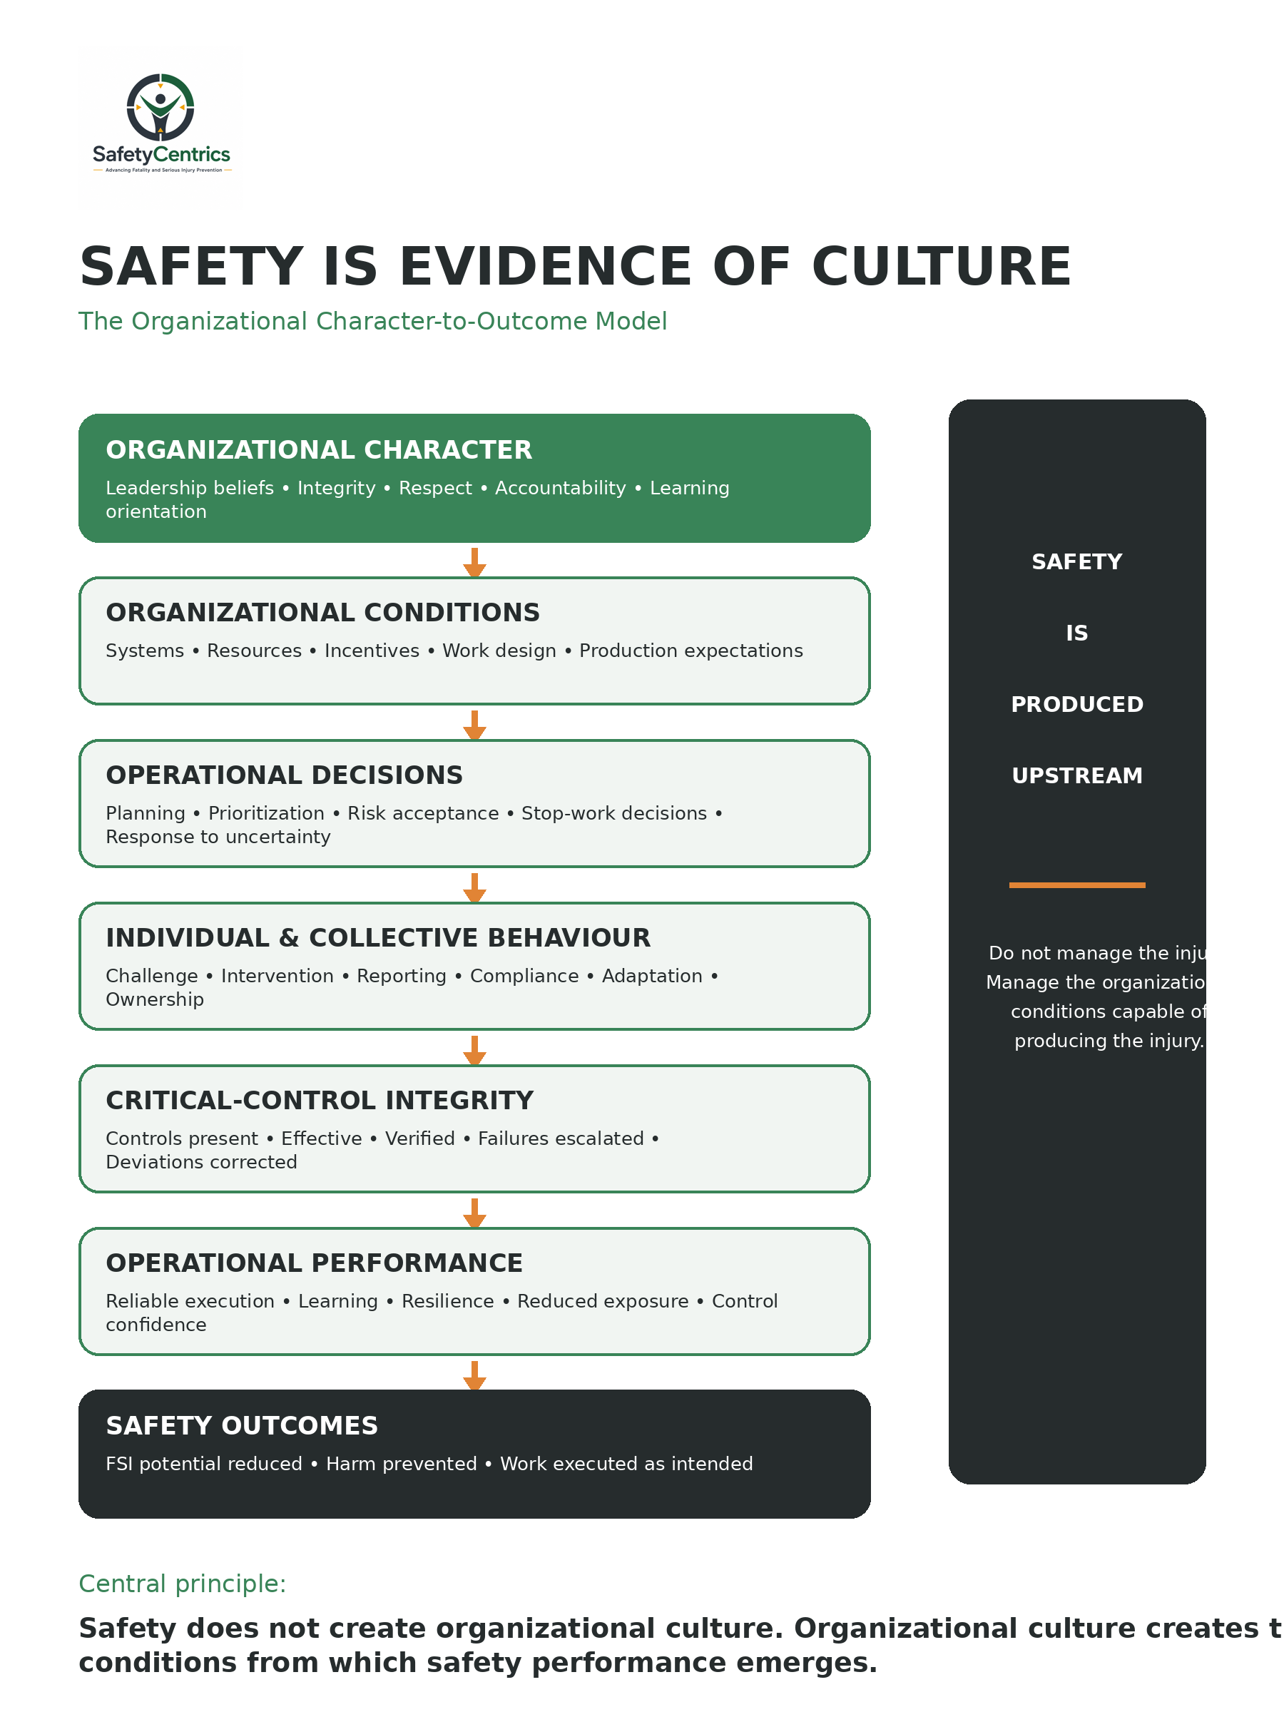
Figure 1. Safety Is Evidence of Culture — the Organizational Character-to-Outcome Model.

19. The Leadership Culture Test
Most organizations can demonstrate strong values when operations are stable. The more meaningful test occurs when those values become inconvenient. Senior leaders should therefore examine what happens when operational objectives compete.
1. What happens when a critical control fails?
Does the organization stop the activity until control integrity is restored, or does pressure emerge to find a way to continue?

2. What happens when someone delivers bad news?
Do leaders thank people for identifying risk early, or does the messenger experience frustration, criticism or career consequences?

3. What happens when production falls behind?
Do standards remain consistent, or do shortcuts, improvisation and temporary exceptions begin to appear?

4. Can a frontline worker genuinely stop work?
A stop-work policy that people fear using is not an effective control.

5. What behavior gets rewarded?
If people who achieve output despite poor control discipline progress faster than those who challenge risk, the organization has communicated its real priorities.

6. What happens when management contributes to an incident?
Does the investigation examine leadership decisions, resources, planning, production pressure, supervision, engineering and organizational systems?

7. Are procedures describing the work people actually perform?
Persistent procedural deviation should trigger organizational curiosity before disciplinary response.

8. How does leadership respond to uncertainty?
When information is incomplete, does the organization slow down, seek expertise and verify controls—or does confidence replace evidence?

9. What happens after repeated weak signals?
Are near misses, control failures, maintenance defects and small deviations connected before serious consequence occurs?

10. Would the same decision be acceptable after a fatality?
If a fatality followed this decision, would leadership still consider the decision reasonable and defensible?

Culture is not tested when everything is going well. Culture is tested when doing the right thing has a cost.

20. What Should Replace Safety Culture?
The purpose of this paper is not necessarily to remove the term safety culture from professional vocabulary. The concept remains useful and deeply embedded in international practice.
The proposed shift is more fundamental: build an organizational culture that produces safe behavior; design organizational conditions that support successful behavior; strengthen the controls and organizational conditions capable of preventing serious events; and place ownership of operational risk within the business rather than within a safety silo.
Protecting people should not be a competing priority. It should be part of how the organization defines competent operation.

21. Discussion
The title of this paper is intentionally provocative. There plainly is an established academic and professional construct called safety culture. The argument is not that the construct should be erased. The argument is that organizations should be cautious about turning it into an organizational silo.
The research underpinning safety culture repeatedly points toward leadership, shared assumptions, management commitment, behavior, systems, learning, trust, communication, work conditions and risk-management practices. These are characteristics of the organization.
Perhaps the most mature interpretation of safety culture is one in which the separate label becomes increasingly unnecessary because safety principles have become embedded into strategy, design, procurement, engineering, operations, maintenance, leadership and decision-making.
When the organization is no longer “doing safety” but simply operating well, cultural integration has become real.

22. Conclusion
Safety culture has contributed significantly to the evolution of occupational health and safety thinking. It helped move organizations beyond purely technical explanations of failure and toward leadership, attitudes, systems and behavior.
The next stage of maturity may require taking that thinking further. Safety does not exist independently from the organization producing it. Leadership decisions, engineering, production systems, maintenance, procurement, supervision, trust and incentives all influence safety outcomes.
The challenge should therefore not be merely to create a strong safety culture within an organization. It should be to create an organization whose character naturally produces disciplined, responsible and safe performance.
When people report uncertainty because that is simply how the organization operates; when supervisors stop work because failed controls are genuinely unacceptable; when leaders welcome bad news because it allows early intervention; when engineers design exposure out of work; and when production success requires control integrity, the organization does not need to continually announce that it possesses a safety culture. Its behavior demonstrates it.
Organizations do not have safety cultures. Organizations have cultures. Safety is evidence of the culture.

References
Cooper, M. D. (2000). Towards a model of safety culture. Safety Science, 36(2), 111–136.
Guldenmund, F. W. (2000). The nature of safety culture: A review of theory and research. Safety Science, 34(1–3), 215–257.
Health and Safety Executive. (n.d.). Organisational culture and human factors guidance. UK Health and Safety Executive.
International Atomic Energy Agency. (1991). Safety Culture: Safety Series No. 75-INSAG-4. Vienna: IAEA.
International Atomic Energy Agency. (2002). Key Practical Issues in Strengthening Safety Culture: INSAG-15. Vienna: IAEA.
International Council on Mining and Metals. (2025). Critical Control Management: Good Practice Guide. London: ICMM.
International Labour Organization. (2003). Safety in Numbers: Pointers for a Global Safety Culture at Work. Geneva: ILO.
International Organization for Standardization. (2018). ISO 45001:2018 Occupational health and safety management systems — Requirements with guidance for use. Geneva: ISO.
Reason, J. (1997). Managing the Risks of Organizational Accidents. Aldershot: Ashgate.
Schein, E. H. (2010). Organizational Culture and Leadership (4th ed.). San Francisco: Jossey-Bass.
Vaughan, D. (1996). The Challenger Launch Decision: Risky Technology, Culture, and Deviance at NASA. Chicago: University of Chicago Press.
Weick, K. E., & Sutcliffe, K. M. (2015). Managing the Unexpected: Sustained Performance in a Complex World (3rd ed.). San Francisco: Jossey-Bass.

Author
James White — Safety Centrics Consulting
Occupational health, safety, operational risk and Fatal & Serious Injury prevention.
Advancing organizational thinking beyond traditional safety management toward operational risk intelligence, behavioral alignment and critical-control integrity.

