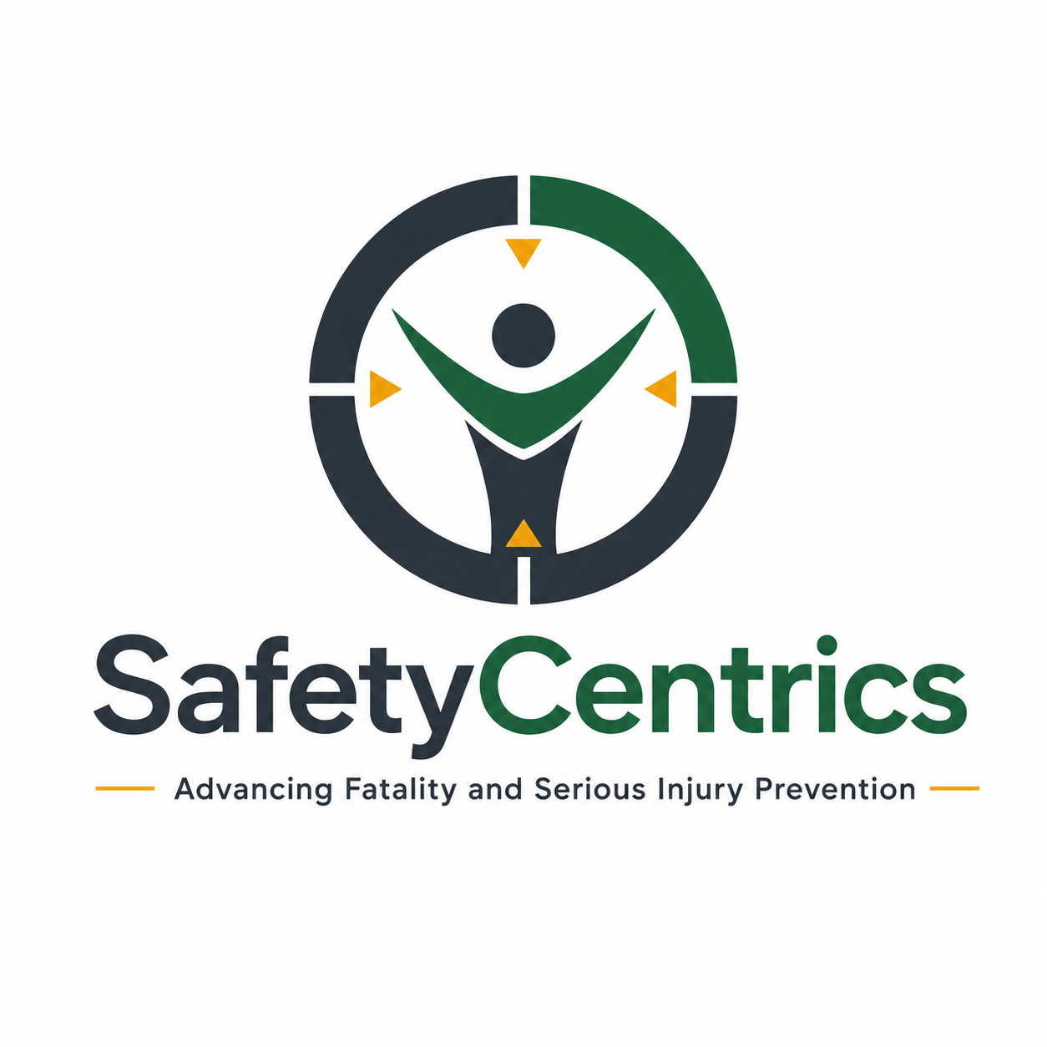
SAFETY AS A PRIORITY
OR SAFETY AS A VALUE?
Reframing the Organizational Belief System for Safety Performance Maturity
A White Paper on Organizational Values, Leadership Behaviour, Behavioral Drift and Operational Integrity

James White
Safety Centrics Consulting
Advancing Fatality and Serious Injury Prevention

Executive Summary
Organizations frequently describe safety as their number one priority. The statement is intended to communicate commitment, yet the language contains an important weakness: priorities are designed to compete and change. Production, cost, schedule, quality, customer commitments and operational continuity all move in response to business conditions. If safety is placed inside that same hierarchy, it can also move.
A value should operate differently. Values establish the principles and boundaries through which competing priorities are pursued. The distinction is therefore not semantic. It affects how organizations respond when protecting people becomes expensive, inconvenient or operationally disruptive.
This paper argues that mature safety performance requires a transition beyond both compliance and the declaration that safety is a core value. The defining test is whether organizational decisions remain consistent with the protection of people when production pressure increases. Safety Centrics describes this progression through five stages: Compliance, Priority, Declared Value, Operational Value and Organizational Character.
The paper also introduces the Belief–Behaviour Gap, the Organizational Moment of Truth and the Belief-to-Performance Model to show how leadership decisions shape operational conditions, workforce behaviour and critical-control effectiveness.
A priority competes. A value governs the decision about what is acceptable when priorities collide.

Key Findings
Finding | Executive Implication
Safety as a priority remains conditional. | Priorities legitimately change with business conditions; safety becomes vulnerable when it is placed inside the same ranking system.
Declared values are not demonstrated values. | Culture is shaped less by corporate statements than by what leaders reward, fund, tolerate and defend under pressure.
The critical maturity transition is behavioural. | The decisive move is from “we believe” to “we decide accordingly.”
Low injury rates do not prove low fatal-risk exposure. | Mature organizations test critical-control effectiveness and exposure rather than relying on outcome statistics alone.
Safety maturity is ultimately organizational character. | The strongest evidence of value is consistent responsible behaviour when nobody is watching and the decision is costly.

Contents
1. The Problem With “Safety First”
2. Priority and Value Are Not the Same Thing
3. The Belief–Behaviour Gap
4. The Organizational Moment of Truth
5. Safety Centrics Organizational Safety Maturity Model
6. Why Organizations Stall
7. From Safety Management to Operational Integrity
8. Safety Maturity Is Not the Absence of Injuries
9. Human Behaviour and Organizational Conditions
10. Stop Work Authority and Cultural Confidence
11. FSI Risk and Critical Controls
12. Leadership Visibility vs Leadership Credibility
13. The Executive Belief Test
14. Recommendations
15. Conclusion
References

1. The Problem With “Safety First”
Few statements are more familiar in occupational health and safety than “Safety is our number one priority.” The intention is positive, but the statement creates a conceptual problem. Organizations do not operate through one permanent priority. They continuously balance production, cost, schedule, quality, workforce availability, equipment reliability, regulatory obligations and customer commitments.
Those demands are legitimate. The weakness appears when safety is positioned as another item inside the same hierarchy. Priorities change because they are expected to change. During stable operations, safety may genuinely sit at the top. During commissioning, shutdown recovery, equipment failure or severe schedule pressure, another objective can quietly become dominant.
Safety culture is not what an organization says it believes. It is what repeated organizational decisions teach people the organization actually believes.
OSHA explicitly recommends making worker safety and health a core organizational value, while HSE guidance treats health and safety management as an integral part of good management rather than a stand-alone system. The practical implication is that worker protection should shape business decisions, not merely compete against them.

2. Priority and Value Are Not the Same Thing
A priority answers a short-term question: What is most important right now? A value answers a more enduring one: What principles govern how we will achieve what is important? This difference changes the decision architecture of the organization.
Under a priority model, safety can be ranked alongside production, cost, schedule and quality. Under a value model, protection of people, integrity and responsibility sit above those objectives and define the boundaries within which they may be pursued.
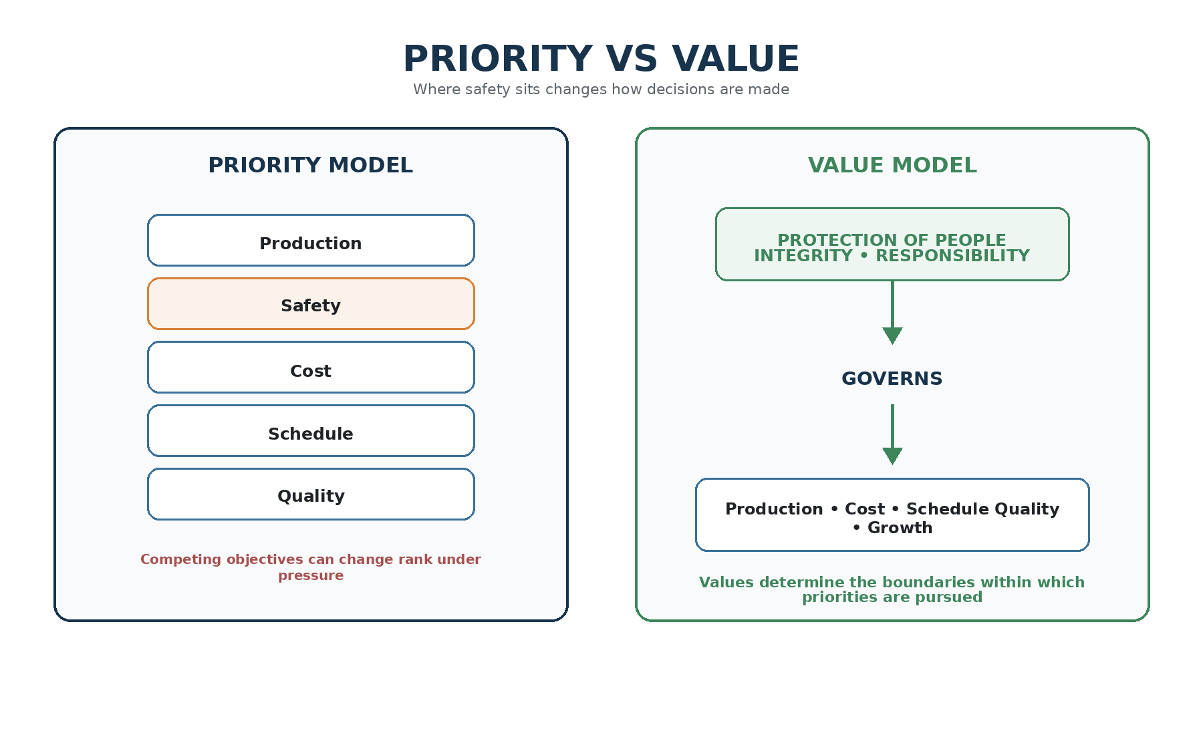
Figure 1. Priority versus Value — safety either competes as an objective or governs the conditions under which objectives are pursued.
Protection of people should not compete with business performance. It should establish the conditions under which business performance is acceptable.

3. The Belief–Behaviour Gap
Changing corporate language from priority to value achieves very little if organizational behaviour remains unchanged. Many businesses declare that safety, people, integrity or zero harm are core values. The meaningful question is whether employees experience those values in decisions that affect real work.
Safety Centrics defines the Belief–Behaviour Gap as the distance between what an organization declares and what its decisions demonstrate. Employees compare words with production decisions, resource allocation, maintenance priorities, contractor treatment, leadership responses and the consequences associated with stopping work.
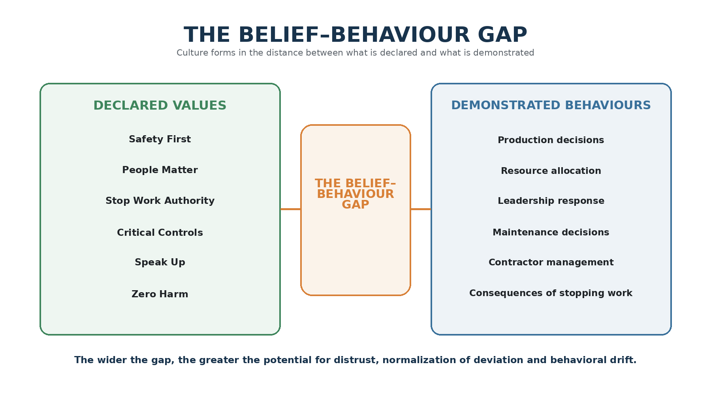
Figure 2. The Belief–Behaviour Gap — the distance between declared values and demonstrated organizational behaviour.
The wider this gap becomes, the less credibility leadership messaging carries. Workers learn which messages are aspirational and which expectations are real. Over time, the demonstrated value normally defeats the declared value.

4. The Organizational Moment of Truth
Almost every organization can support safety when doing so carries little operational consequence. The real test begins when protecting people delays production, extends a shutdown, requires capital, interrupts commissioning, rejects a contractor, or challenges a senior operational decision.
These moments are culturally powerful because everyone watches what happens next. Does leadership accept the consequence? Does the organization search for a workaround? Is the person who stopped work supported or quietly criticized? One decision may appear small; hundreds of similar decisions create organizational belief.
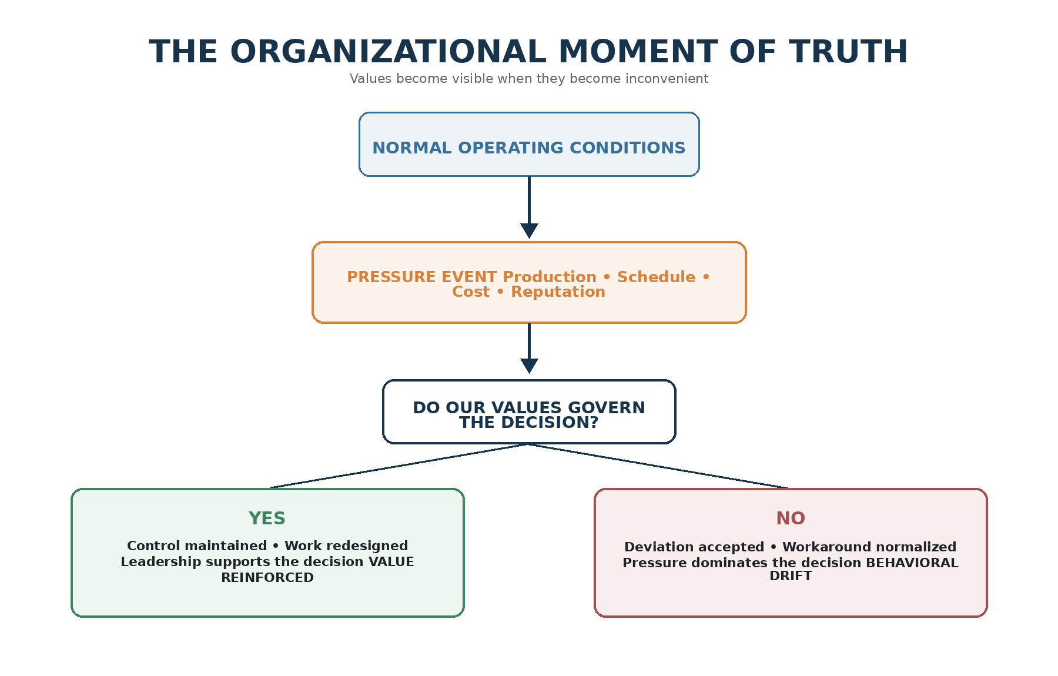
Figure 3. The Organizational Moment of Truth — business pressure exposes whether stated values actually govern decisions.
Values become visible when they become inconvenient.

5. Safety Centrics Organizational Safety Maturity Model
Safety Centrics proposes five broad stages of safety performance maturity. The stages are not intended as a certification scale. They provide a practical lens for examining what fundamentally drives behaviour inside the organization.
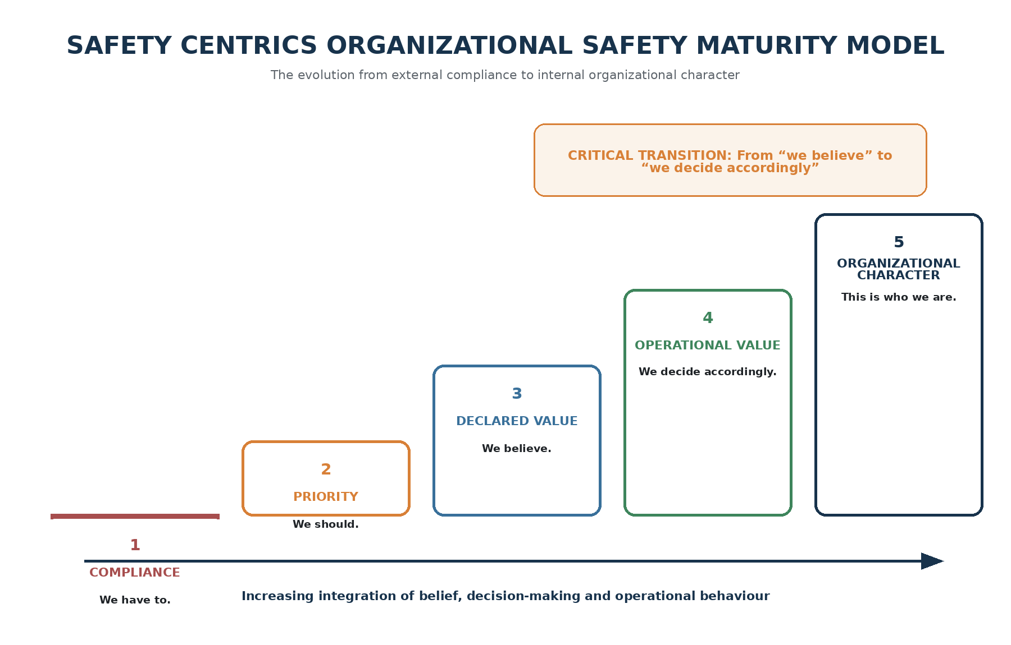
Figure 4. Safety Centrics Organizational Safety Maturity Model — the progression from compliance to organizational character.
- Level 1 — Compliance: “We have to.” Safety is driven principally by legislation, rules, procedures, audits and enforcement.
- Level 2 — Priority: “We should.” Safety receives visible management attention but remains capable of competing with production, cost and schedule.
- Level 3 — Declared Value: “We believe.” Corporate language, leadership commitments and engagement strengthen, but a gap may remain between belief and operational decisions.
- Level 4 — Operational Value: “We decide accordingly.” Worker protection is integrated into capital allocation, engineering, procurement, maintenance, contractor selection, planning and leadership evaluation.
- Level 5 — Organizational Character: “This is who we are.” Responsible risk decisions occur consistently because they have become part of normal organizational identity.
The decisive transition is not from priority to value. It is from declared value to demonstrated operational value.

6. Why Organizations Stall
Organizations can possess sophisticated management systems, competent safety teams, experienced leaders and sincere intentions while remaining culturally immature. The reason is often systemic misalignment. The organization asks for one behaviour while the surrounding business architecture rewards another.
- The organization says “stop when uncertain,” while schedule systems reward certainty and uninterrupted execution.
- The organization says “report everything,” while leaders react negatively to bad news or repeated deficiencies.
- The organization says critical controls are mandatory, while informal exceptions are tolerated during production pressure.
- The organization says safety belongs to everyone, while operational leaders continue to treat the safety department as the owner of risk.
The issue is therefore not simply motivation. It is whether organizational systems, incentives and leadership responses align with the behaviours being requested.
Organizations cannot sustainably ask people to demonstrate behaviours that their operating environment repeatedly discourages.

7. From Safety Management to Operational Integrity
One of the enduring weaknesses in safety management is the artificial separation between doing the work and doing the work safely. Operations perform; safety monitors; leadership reviews. This can unintentionally communicate that safety is a specialist function added to operational activity rather than a characteristic of competent operational execution.
A mature organization increasingly asks not “What does safety require?” but “What does controlled and competent execution require?” HSE’s HSG65 reinforces this integration by treating health and safety as part of good management generally. ISO 45001 similarly emphasizes leadership, worker participation and integration with organizational processes.
The mature operating model has one standard: the right work, performed the right way, with the controls required to manage unacceptable risk.

8. Safety Maturity Is Not the Absence of Injuries
Low injury frequency can coexist with significant fatal and serious injury exposure. An organization may go months without a recordable event while repeatedly operating with degraded controls, normalized workarounds or weak verification. The absence of harm may reflect successful control — or simply the absence of consequence.
This is why mature safety performance moves beyond asking only how many people were injured. It asks whether serious harm was adequately controlled. ICMM’s published analysis of member safety data has highlighted the central role of critical-control effectiveness in fatality prevention, reinforcing the need to focus on exposure and control performance rather than lagging outcomes alone.
Absence of injury is not necessarily evidence of presence of control.

9. Human Behaviour and Organizational Conditions
Unsafe behaviour is often treated as an individual problem: someone bypassed a procedure, missed a hazard, failed to verify a control or continued despite abnormal conditions. These observations may be factually correct but still causally incomplete.
HSE’s human-factors guidance emphasizes that behaviour is influenced by organizational, job and individual factors. The more useful organizational question is therefore not simply why the worker behaved as they did, but what conditions made that behaviour appear reasonable, necessary, efficient or normal at the time.
Production pressure, fatigue, resource availability, equipment condition, procedure quality, supervisory expectations and previous successful deviations all shape decisions. What the organization repeatedly tolerates can eventually become what the workforce interprets as acceptable.
Behavioral drift becomes organizational drift when repeated adaptations are rewarded by successful outcomes and left unchallenged.

10. Stop Work Authority and Cultural Confidence
Many organizations state that every employee has stop-work authority. Fewer test whether employees possess stop-work confidence. Authority exists in policy; confidence exists in culture.
A worker may technically be authorized to stop a task yet still anticipate ridicule, supervisory frustration, production consequences, peer pressure or commercial repercussions. In that environment, policy authority becomes theoretical. The mature test is whether employees genuinely believe that the organization will support a justified stop-work decision even when it carries operational cost.
Policy creates authority. Culture creates confidence.

11. FSI Risk and Critical Controls
The distinction between stated value and demonstrated value becomes especially visible in fatal and serious injury risk. For high-consequence exposures, organizations should be able to answer a disciplined sequence of questions: What can kill or permanently disable someone? What controls prevent that outcome? Which controls are critical? How is their presence and effectiveness verified? Who owns the verification? What happens when a critical control is unavailable?
The last question is revealing. If the loss of a critical control does not materially change the decision to proceed, then the control may be described as critical without being treated as critical.
A critical control is only truly critical if its absence changes the decision to proceed.

12. Leadership Visibility vs Leadership Credibility
Leadership visibility matters, but visibility without consistency can become theatre. Safety walks, town halls and field engagements have limited value when everyday operating decisions send a contradictory message.
Workers evaluate leaders through alignment: what they say, measure, reward, fund, tolerate and personally do. The leadership decision made during operational pressure normally carries more cultural weight than the speech delivered when conditions are easy.
Credibility therefore emerges when workers can predict that the organization will make substantially the same risk decision regardless of who is watching, how important the production target is, or how inconvenient the consequence becomes.

13. The Executive Belief Test
Executives and boards can test organizational maturity by asking questions that conventional safety statistics rarely answer. These questions focus attention on demonstrated behaviour rather than corporate intent.
- What happened the last time someone stopped an important operation?
- Where are we knowingly operating with degraded critical controls?
- Are leaders rewarded for how results are achieved, or only for the result?
- What bad news are people reluctant to tell us?
- Where are workers routinely compensating for weak systems or equipment?
- Which shortcuts have become normalized because nothing bad has happened?
- Does our capital allocation reflect our stated safety values?
- Would we make the same risk decision if nobody outside the organization would ever know?
Do not ask whether safety is a value. Ask what happens when protecting people interrupts production.

14. Recommendations
Organizations seeking to move from safety as a priority toward safety as an embedded operating value should focus on the mechanisms that convert belief into behaviour.
1. Reframe the language. Replace simplistic “Safety First” messaging with a clear performance expectation: business objectives will be achieved without exposing people to unacceptable risk.
2. Align leadership incentives. Evaluate leaders on how results are achieved, including critical-control discipline, reporting transparency, intervention quality and exposure reduction.
3. Integrate safety into business decisions. Embed worker protection and risk criteria into engineering, procurement, contractor selection, maintenance, capital allocation and operational readiness.
4. Measure exposure, not only outcomes. Use leading measures that test critical-control effectiveness, weak signals and risk conditions rather than relying principally on injury frequency.
5. Strengthen operational ownership. Operations should own the risks created by the work; safety functions should provide expertise, challenge, assurance and risk intelligence.
6. Test stop-work confidence. Measure whether people believe they will be supported when they interrupt work for legitimate risk concerns.
7. Investigate organizational conditions. Move beyond the worker closest to the event and examine incentives, resources, leadership decisions and normalized adaptations.
8. Verify values under pressure. Review major operational decisions where cost, schedule or production competed with risk controls. These decisions provide the clearest evidence of organizational maturity.

15. Conclusion
Safety as a priority represented progress. It elevated worker protection and placed it onto the executive agenda. But priorities remain vulnerable because priorities compete. Declaring safety to be a value is stronger, but the declaration itself is not maturity.
The deeper objective is an organizational belief system in which protection of people is embedded within the decisions that define acceptable performance. At that point safety no longer competes against production; it defines the conditions under which production is acceptable. It no longer belongs to the safety department; risk belongs to the business. Leadership no longer proves commitment primarily through messaging; it proves commitment through decisions.
The ultimate measure is therefore not whether an organization calls safety its greatest priority or even a core value. The better question is whether the organization continues to make decisions consistent with protection of people when doing so becomes difficult, expensive or inconvenient.
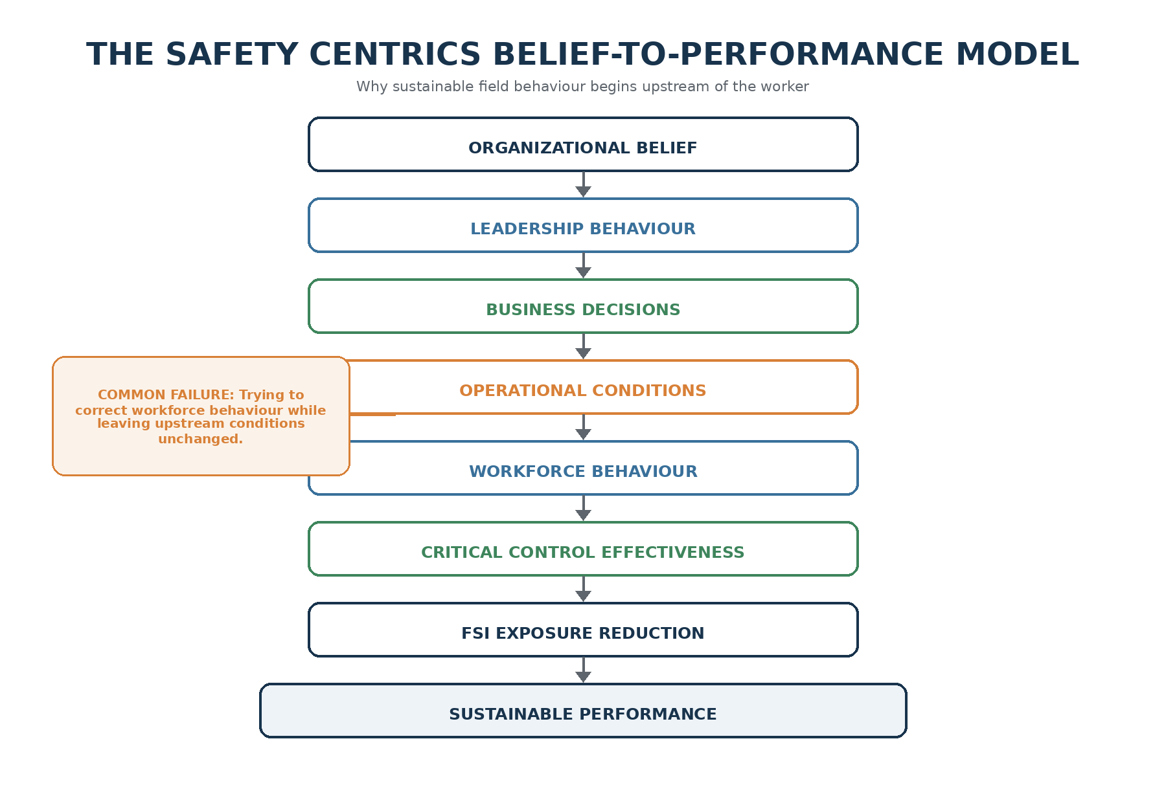
Figure 5. Safety Centrics Belief-to-Performance Model — sustainable field behaviour is shaped by upstream beliefs, leadership decisions and operational conditions.
Priorities determine what we need to achieve. Values determine how we are prepared to achieve it. Culture determines what people normally do. Character determines what the organization refuses to compromise.

References
Health and Safety Executive (HSE). Managing for Health and Safety (HSG65). Updated 2025. https://www.hse.gov.uk/pubns/books/hsg65.htm
Health and Safety Executive (HSE). Organisational Culture: Overview. Updated 2026. https://www.hse.gov.uk/humanfactors/topics/culture.htm
Health and Safety Executive (HSE). Introduction to Human Factors. https://www.hse.gov.uk/humanfactors/introduction.htm
Health and Safety Executive (HSE). Leading Health and Safety at Work (INDG417). https://www.hse.gov.uk/pubns/indg417.htm
International Council on Mining and Metals (ICMM). 2020–2024 ICMM Safety Performance: Insights. 2025. https://www.icmm.com/en-gb/research/health-safety/2025/insights-2020-2024-safety-data
International Organization for Standardization (ISO). ISO 45001:2018 — Occupational health and safety management systems. https://www.iso.org/standard/63787.html
Occupational Safety and Health Administration (OSHA). Recommended Practices for Safety and Health Programs. https://www.osha.gov/safety-management
Occupational Safety and Health Administration (OSHA). Management Leadership. https://www.osha.gov/safety-management/management-leadership
Occupational Safety and Health Administration (OSHA). Safety as a Core Value. https://www.osha.gov/safety-management/safety-core-value
Occupational Safety and Health Administration (OSHA). Worker Participation. https://www.osha.gov/safety-management/worker-participation

About Safety Centrics Consulting
Safety Centrics Consulting supports organizations in strengthening occupational health and safety, fatal and serious injury prevention, operational risk management, critical-control performance and organizational safety maturity. The focus is not on creating more safety activity, but on strengthening the leadership behaviours, operational decisions and control systems that protect people and sustain performance.
Safety Centrics Consulting | Advancing Fatality and Serious Injury Prevention

